Uniform policy.

Trewirgie Infants’ & Nursery School

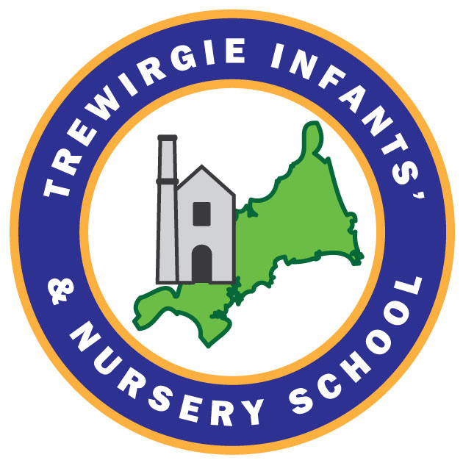

Approved by: | C Callow | Date: September 2023
Last reviewed on: | September 2023
Next review due by: | September 2024

Person responsible for Implementation and Monitoring: Headteacher
Links to other relevant policies: Safeguarding Policy, Behaviour Policy

- Introduction

This policy has been put in place to ensure that the School’s requirements for student uniform and appearance are aligned with the revised Department for Education Guidance (Statutory and Non-Statutory 2021). This policy complies with the Human Rights Act 1998 and Equality Act 2010 and takes into account key considerations such as safeguarding and health and safety.
Our Governing Body decides what the School rules are for student appearance (including uniform) and how the uniform should be sourced. We believe that our rules on Uniform and Appearance have a key role in promoting:
- The ethos of the school
- A sense of belonging, community and identity
- An appropriate tone for education
We believe that a consistent standard of appearance and uniform may act as a social leveller by creating a common sense of identity amongst students. It may reduce bullying and peer pressure to wear the latest fashion or other expensive clothes.
In reviewing and implementing this policy, Governors will take into account the views of parents and pupils when making any significant changes. Governors will also take into account:
- How the rules on uniform and appearance may affect groups represented in the school, especially those who share relevant protected characteristics (sex, religion or belief, race, disability, gender reassignment, pregnancy)
- How comfortable the uniform will be for students
- How practical the uniform is in classroom settings, including those where practical work is required
- That reasonable adaptations will be made for extreme weather (hot or cold)
- That the uniform is suitable for pupils who walk or cycle to school
- That a PE kit must be practical, comfortable and appropriate to the activities and affordable
- That the cost of the uniform does not place an unreasonable financial burden on families and would not, for example, prevent a child from a low income family from attending the school
- Where reasonable and as far as possible, the environmental impact of the production and supply of uniform.
The school’s expectations for uniform and appearance are therefore intended to be inclusive so that all pupils are able to wear the uniform and have the appropriate appearance.
- Religion or Beliefs
Some religions or beliefs require their adherents to conform to a particular dress code. This could include wearing or carrying specific religious artefacts, not cutting hair, dressing modestly, or covering their head. Pupils have a right to manifest a region or belief, but not necessarily at all times, places or in a particular manner.
Where the school has good reason, it may lawfully need to restrict an individual’s freedoms regarding uniform and/or appearance. This may include, for example, for the promotion of cohesion or good order, or genuine health and safety or security reasons.
The school will act reasonably in accommodating the needs of different cultures, races and religions, without compromising important school policies such as school discipline and safety.
- Discrimination
In developing and implementing this policy, the school has carefully considered its obligations not to discriminate unlawfully. For example, the school has lawfully designated different uniform requirements for boys and girls and has ensured that these are broadly equivalent in terms of financial cost.
This policy ensures that no particular group (including those with protected characteristics) is impacted unfairly as far as is reasonably possible. In some circumstances, e.g. for pupils with a disability, the school will make reasonable individual adjustments to the uniform policy.
- Affordability
The cost of uniform should not prevent a family from applying for a place in our School nor prevent a child from attending. The use of branded items within the School Uniform Policy has been kept to a minimum.
Second hand uniform items are available on request from the School. The school will accept donations of second hand uniform providing these are clean and in excellent repair. Parents wishing to donate uniform should contact their child’s teacher or year leader. The school recognises that second hand uniform extends the life of garments, reducing the environmental impact of uniform.
Uniform and rules on appearance will be reviewed bi-annually and frequent significant changes will be avoided as these may be expensive for families. Where significant changes are made, these will be phased in to allow pupils to continue to wear the old uniform for a reasonable period of time. This includes pupils in Year 5, 6, 10 and 11, for whom the purchase of new uniform items in the later stages of the academic year may not be cost effective for families.
The requirement to wear branded items of uniform has been kept to a minimum within our Uniform Policy.
The majority of unbranded uniform items e.g. socks, school shirts and trousers, can be purchased from a range of retailers giving parents choice and value for money.
All school uniform items should be available as machine washable.
- PE Kit
No pupil should be unable to participate in school sporting activities because of the cost of PE kit. Therefore the use of branded items, and the range of different items of PE Kit in our Policy, will be kept as low as possible.
- Uniform Suppliers
Governors will review the school’s uniform suppliers at least every 5 years. In reviewing the suppliers, Governors will take into account the affordability of uniform as well as its quality and durability. The uniform supplier will be required to publish and operate their own complaint procedure in order to manage any parental concerns.
Governors will take into account the accessibility of the provider, ensuring parents can arrange convenient ordering, collection/ delivery of school uniform items. This includes the availability of an online uniform shop.
- Clarity
The school will ensure that its rules on uniform and appearance are clear and unambiguous and easily accessible to parents via the school website. This is to ensure that parents do not commit to buying costly uniform, or, for example, costly hair styles or piercings, which are not acceptable to the school. The school will ensure that any ‘optional’ items of uniform are clearly designated as such, and will minimise the use of ‘optional’ uniform items. The school will also ensure that branded items, or those which have to be purchased from a particular supplier, are clearly indicated. Parents with a query about Uniform or Appearance should contact the School to seek clarification of the rules prior to committing to purchase. The School will review the wording of the Uniform and Appearance rules in response to parental queries where it appears that the wording is unclear.

- Student Non-Compliance
All pupils are expected to comply with the school’s rules on uniform and appearance. The school believes that all pupils should comply with these rules, and that non-compliance is unnecessarily disruptive to education. Students with incorrect uniform or appearance will be challenged by staff and expected to rectify their uniform/ appearance immediately (where possible e.g. by removing the jewellery or non-uniform item) or as soon as possible where the issue cannot be solved immediately. Where a breach of uniform or appearance cannot be resolved in school, the student may be sent home to change/ correct their appearance. Parents will be informed. In line with DfE guidance, this is not an exclusion and the students’ absence will be unauthorised. Confrontational behaviour by students and refusal to follow staff instructions in response to staff requests to correct uniform or appearance is unacceptable and will be managed under the school Behaviour Policy. Students may be disciplined for breaching the school rules on appearance or uniform, in line with the school’s Behaviour Policy.
Where financial hardship has resulted in a student not complying with the school’s published rules on uniform or appearance, then the school will take a considerate approach to assist the student and family to resolve the situation.
Where the school has made individual adaptations to the rules on uniform or appearance in response to a child’s individual needs e.g. a disability, then the School will ensure that all staff are aware. This includes, wherever possible, supply and temporary staff. This is to minimise the occasions on which a student is challenged about their uniform or appearance.
- Concerns and complaints
In line with the TPAT Complaint Procedure, parents with a concern about this policy, or the implementation of the Uniform Policy, should first contact the school and seek to resolve this concern informally. Where an acceptable resolution cannot be agreed, parents should follow the Complaint Procedure, available on the school website. Hard copies of the Complaint Policy are available on request from Reception.

Appendix 1: Trewirgie Infants’ School… Uniform and Appearance Policy
Boys Winter Uniform – Grey or black trousers, white shirt, royal blue with a thin gold stripe tie, royal blue V-neck jumper and black shoes.
Boys Summer Uniform - Grey or black shorts, white shirt, royal blue with a thin gold stripe tie, royal blue V-neck jumper and black shoes.
Girls Winter Uniform – Royal blue pinafore or skirt, white shirt, royal blue with a thin gold strip tie, royal blue cardigan and black shoes.
Girls Summer Uniform – Royal blue and white summer dress, royal blue cardigan and black shoes.
Boys and Girls PE Kit – Yellow t-shirt, royal blue shorts and black plimsolls.
Boys and Girls Winder PE Kit – As above with a dark coloured tracksuit.

