Nutrition and Safer Eating Policy

Trewirgie Infants’ & Nursery School

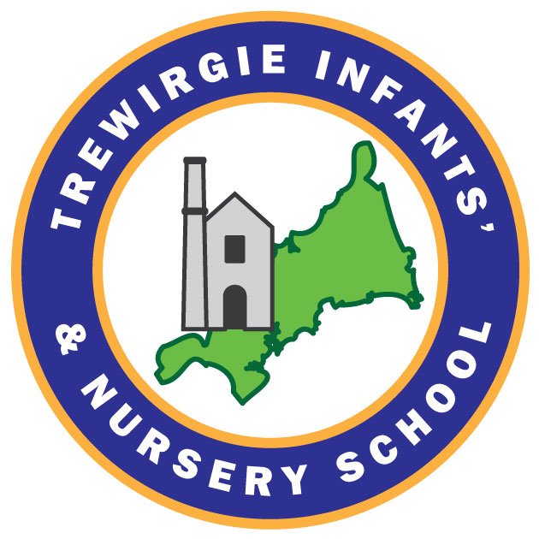

Last reviewed on: 05.09.2025
Next review due by: September 2026

Contents
1. Nutrition and Healthy Eating 3
2. Procedures to Promote Good Nutrition & Safer Eating 3
3. Hot School Lunches 4
4. Packed Lunches 4
5. Monitoring and Review 5

- Nutrition and Healthy Eating
Providing healthy, balanced and nutritious food ensures that all children:
- Get the right amount of nutrients and energy they need while they are growing rapidly. This is especially important for children who might not have access to healthy food at home. This can help prevent children from becoming overweight or obese.
- Develop positive eating habits early on. Children’s early experiences with food can shape future eating habits, impacting their long-term health, including maintaining a healthy weight and good oral health.

At Trewirgie we use our daily routines to promote health and wellbeing practices. Our snack and lunch times are an important social time for our children and the adults they work alongside. These times are valuable opportunities to support, develop and enhance children’s learning and development. Children at Trewirgie learn about nutrition through opportunities to explore new foods alongside their peers. The individual dietary needs of all children are meet at snack and lunch times and the food provided is nutritious. Children are involved in the routine preparation of snack time and we promote their independence by allowing them to choose their snack and pour their own drinks. Adults talk with the children about the different foods we eat to extend their knowledge about how different foods and diets impact our health.

- Procedures to Promote Good Nutrition and Safer Eating
- During the enrolment process we gather information about each child’s dietary needs on our enrolment form, preferences, this includes information including allergies and religious/cultural diets.
- Parents are regularly consult to ensure our dietary records, including allergies, are up to date.
- All staff working with the child are made aware of the individual dietary needs of the child.
- EYFS staff are trained in food hygiene and allergen awareness and follow government advice on the hazards of choking. Food is prepared in line with children’s ages, stages and individual needs, using NHS guidance on safe eating.
- At each snack and lunch time the class teacher is responsible for checking the food provided meets all the dietary requirements for each child.
- Staff sit with the children during snack times, we value these times and use it to promote conversations and discussions.
- During lunch time adults ensure they can see and hear children at all times.
- Within the EYFS a qualified Paediatric First Aider is in the room at all times during every snack/meal time.
- In the event of a child experiencing a choking incident, the teacher will record details of what happened and where it happened, this will be shared with the parents and reported to the Head Teacher.
- We provide a range of nutritious snacks, these include a range of fresh fruit and vegetables.
- We include a variety of foods from the four main food groups in line with the government ‘Eatwell Guide’: Fish, meat and protein alternatives such as beans/pulses, Carbohydrates, Dairy/ non dairy alternatives & Fresh fruit & Vegetables.
- We offer foods from different cultures to provide both familiar and new experiences.
- We help children develop independence by allowing them to make choices their own food choices.
- Whenever possible, children help prepare food and set the snack table.
- Children have their own individual, named bottle in school. Fresh drinking water is always available and children are reminded they can access it at any time. During warmer weather and after physical activity we encourage children to hydrate.
- Children are not allowed to share or swap food, ensuring our children with allergies are protected.
- Children with food allergies are always served their lunch first and wear a pink band to show the kitchen staff.
- We offer milk as an alternative to water during snack times. Water is always available.

- Hot School Lunches
Hot school lunches are available to all children from their Reception year. All children in Reception, Year 1, and Year 2 are entitled to a universal free school meal. This can be ordered daily or in advance and all meals are prepared in the school kitchen. Menus are shared with parents each term.

- Packed Lunches
At Trewirgie we aim to support children to develop healthy food habits. We encourage packed lunches to include a variety of foods from the four main food groups. If you would like more information regarding ideas for packed lunches or information on the four main food groups please see the links below. Packed lunches should include a freezer pack to prevent food spoilage.
https://www.nhs.uk/healthier-families/recipes/healthier-lunchboxes/
https://www.healthycornwall.org.uk/media/riqo4w41/under-5-s-healthy-lunchbox-card_a5_web.pdf

We offer support to families who would like more information regarding food choices for their child, including knowing how to pack a healthy, well-balanced lunch.
When a child has finished their lunch any uneaten food is returned in lunchboxes so that parents are aware of what their child is eating at school.

- Monitoring and Review
This policy is reviewed annually and updated in response to new government guidance or changes in practice. We welcome parent/carer feedback and value working in partnership with our families.

