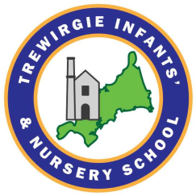

Trewirgie Infants’ & Nursery School
Strategy for 2026 – 2027
INTENT
· All staff to have a clear vision of science and how it is taught at Trewirgie Infants’ & Nursery School progressively across the year groups.
· High quality, fun and engaging lessons planned to be inclusive and accessible to all children.
· All Children to develop a love of Science and be curious and actively mindful learners , asking questions and following their own lines of enquiry to support the curriculum but their own love of science.
· For all children to be scientific investigators, having the skills to record their findings accurately and talk about their learning as evidence of their knowledge and understanding.
· All staff following the school’s science progression of skills with a clear assessment system where assessment takes place prior and after each unit
Staff being clear on the progression of learning that comes before and after each lesson and how they all build and progress throughout the school setting from EYFS to Year2.
. All science books to have clear dates, L.O.’S, following a sequence showing pride and regard for presentation.

Curriculum overview
To ensure that high quality science is taking place throughout the whole school we implement a curriculum which is progressive from EYFS through to Year 2. Teachers follow the science skills progression document that incorporates the National Curriculum objectives but also goes beyond them. Our science curriculum aims to inspire children’s curiosity and interest to explore the world that we live in and recognise that science is an exciting and crucial part of everyday life. Teachers plan and deliver quality lessons that increase children’s’ knowledge and understanding of our world, and with developing skills associated with science as a process of enquiry. It will develop the natural curiosity of the child, encourage respect for living organisms and the physical environment and provide opportunities for critical evaluation of investigations.

Implementation
All KS1 use the same lesson plan format plan their science lessons with accuracy and detail. When possible, this includes a linking text to the topic EG. Monkey puzzle for Animals and Humans (Lifecycles). The little Seed (Plants) and Super worm (Habitats). As a school, we are passionate about reading cross curricular. We found that this has supported and engaged children with their topic learning.

New and specific vocabulary is taught and explained at the beginning of each topic to enhance children’s understanding of science. Within lesson, they use careful questioning to stop and assess if there are any misconceptions. If there are, they are corrected before the teacher moves on, but these misconceptions are revisited throughout the lesson to ensure everyone is secure in the learning by the end. Sometimes, this means taking a child or group of children during the lesson for extra support. If the plenary at the end shows that the children are not secure, then the learning will be revisited the next lesson as part of their retrieval.
Each unit starts with an assessment to gauge the starting point of each child’s understanding and it will be repeated at the end of the unit to see what knowledge they’ve gained. Each lesson starts with a retrieval task linked to previous learning, then an oracy task linked to the new learning. During the lessons, there are mini retrieval questions to see if the children can apply previous knowledge and learning to new learning. At the end of every lesson is a reflective plenary of the content that was taught and next steps on how that will link to the next sequence of learning. Retrieval tasks are given at a distance (between topic subject) to assess long term memory assimilation. Assessment tasks are carefully thought out and vary on the unit. Each assessment task is accessible to all children and adapted for SEND children.
Those assessments identify gaps or weakness in knowledge that is then revisited and built into another unit as retrieval tasks or mini quizzes.
Teachers create effective displays that show the key scientific vocabulary, examples of children’s work and have resources on display to support learning.
Approaches to teaching
Science lessons are planned to fit in with each year groups focus and in EYFS & Year1 to follow the seasons and the world around them. The lessons have a strong focus on vocabulary which ensures that all children are able to talk about science using the appropriate language and understanding. To support this, teachers produce vocabulary grids at the start of each new unit to introduce the new vocab and their meanings.

Timetable
Science at EYFS is covered in the ‘Understanding the World’ area of the EYFS Curriculum.
It is introduced mostly indirectly through activities that encourage children.
Long term and medium-term plans show when and what unit of science is being taught in KS1, these are regularly reviewed by the subject leader and teachers to ensure that units remain engaging and exciting to the children to explore, problem solve, observe, predict, think, make decisions and talk about the world around them.
In KS1 science is taught in unit blocks, which are outlined in the long-term planning.

Approaches to supporting disadvantaged and SEND children
Science lessons need to be accessible to all and inclusive. Potential barriers to learning need to be considered so planning can minimise or reduce them so that all children can fully take part and learn in the same way as their peers. Any adaptations for children with SEND will be considered carefully, considering their individual barriers and the support needed to achieve their learning goals.

Impact
End of KS1 data showed that our children were above national expectations for science. Their pupil voice and books provided evidence of their love and coverage of science. In lessons, the children have shown to be more inquisitive, curious and have a greater understanding of the world around them, communicating their understanding using the correct scientific vocabulary and retrieving prior learning. They can apply reasoning, enquiry, and communication skills to all aspects of their everyday lives. They can apply their knowledge across other subject areas like comparing houses in Africa with houses in the UK. Comparing the uses of everyday materials to different places. Another example, knowing what types of plants can grow in different hot and cold countries because they remember what plants need to grow healthy. Our children know how roads are built and the materials that are used to build them because they study famous inventors. Because our children have the experiences of meeting everyday scientists within the community, discussing their roles and important contributions to science or the application of it in our daily lives. Our children leave our school inspired by science and understand how vital it is to the world’s future development by participating in World Science Day and Science weeks.
EYFS and all KS1 classes have a science floor book to capture what science looks like in their class and examples of working scientifically. These are show the progression of their scientific journey as the book moves through the school with them.

Future impact: Moving forward with developing outdoor science areas in Ks1, children will thrive even more in the excitement of being scientists and contributing themselves to develop their environment for curiosity and learning.

Successful engagement in 2026

Parents have been fully engaged and complimentary about our science curriculum. They especially appreciate and like the hands-on approach to science with the planned investigations and enriching school trips such as Eden Project, Trips to the woods, growing their own apples in the Early Years provision.

Many parents have contributed their time and expertise coming into school to talk about the role of science in their jobs and lots of others have supported their children with science homework projects to enhance their curriculum in school.

This year, our after school gardening club run by teaching staff has been incredibly popular and will continue to run next academic year.

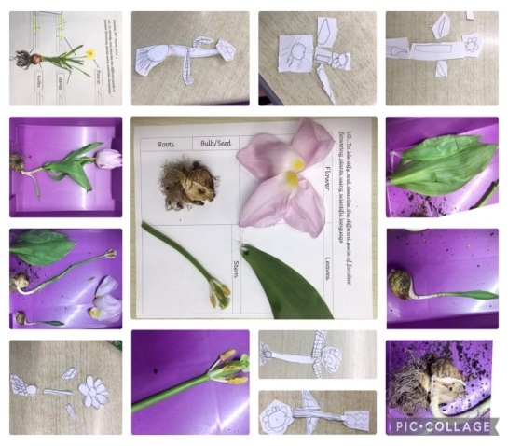
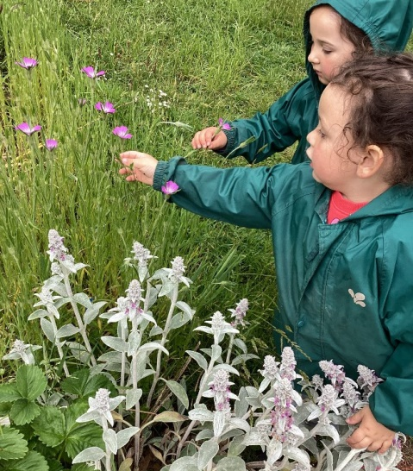
We have establish community links with our secondary school in Redruth to participate in Science week assemblies and start forward planning for more opportunities between the schools.
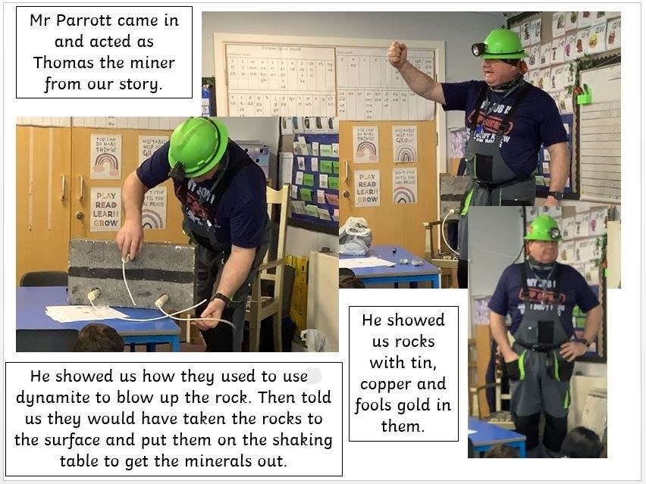
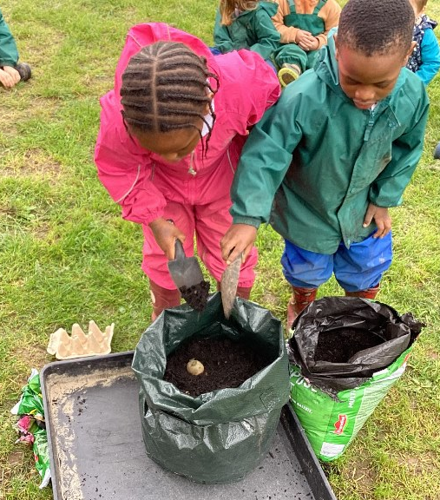

Future aspirations for 2027
- Being involved with projects at the Eden Project
- Developing a school Stem after school club
- Develop the role of science champions in the school

