Handwriting Progression Document
 |  | RWI Letter Formation | Nelson Handwriting Scheme
 | Nursery | Year R | Year 1 | Year 2
Aut 1 | - gross motor skills  - fine motor skills  - mark making  - beginning letter shapes | - gross motor skills  - fine motor skills  - mark making  - RWI letter formation | RWI letter formation  Fine motor skills – funky fingers | Individual letter joins and review horizontal joins
Aut 2 |  |  | Fine motor skills – funky fingers  Letter formation families | Individual letter joins and review horizontal joins
Spr 1 |  |  | Letter formation families  Capitals, numbers, height of letters | Individual letter joins and review horizontal joins
Spr 2 |  |  | Diagonal joins | Diagonal joins
Sum 1 |  |  | Horizontal joins | Review the four joins
Sum 2 |  |  | Review diagonal and horizontal joins | Review the four joins

 | Lines Progression
 | Nursery | Year R | Year 1 | Year 2
Aut 1 |  | 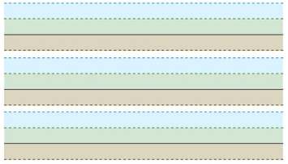  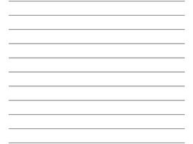  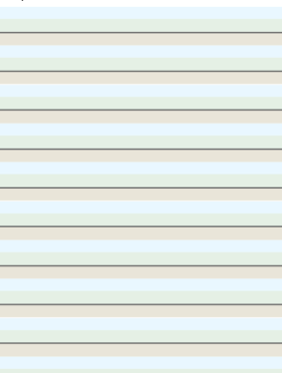 | 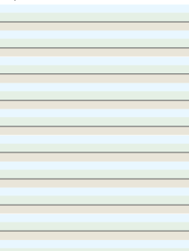   | 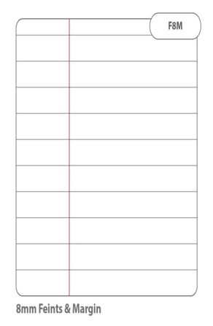  
Aut 2

Spr 1

Spr 2

Sum 1
Sum 2

