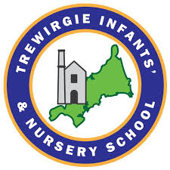
Design Technology Progression of Skills
OUR VISION FOR TREWIRGIE INFANTS’SCHOOL
‘We care, we help, we succeed’
OUR MISSION:
- To inspire children to engage in learning, and be valued members of a caring, supportive, and successful school.
- For all our children to develop life- long learning skills; to be independent and creative thinkers and to be socially confident.
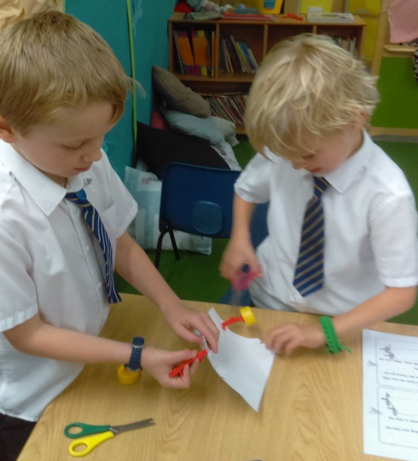
- To enable children to be successful through a curriculum that captures their interests, stimulates their ideas, encourages inquisitiveness and critical thinking and meets their needs.

At Trewirgie Infants’ and Nursery School, our children have opportunities to use their imaginations and be inspired to design and make products that solve real and relevant problems that they want to create. We believe that Design & Technology should be about supporting pupils to take risks, becoming innovative and creative citizens for the world in which they live. Through the evaluation of Design and Technology we want to inspire children to understand the impact of design and technology and its essential contribution that creativity brings to the evolving world around them. We ensure that all children learn about Design & Technology through a variety of projects that are woven through our creative cross curricular learning. Through the development of skills children can design appealing products for themselves and evaluate existing products and discuss improvements to their designs and products.

“Creativity is intelligence having fun” Albert Einstein

Curriculum statement
INTENT  (curriculum design, coverage and appropriateness) | IMPLEMENTATION  (curriculum delivery, teaching and assessment) | IMPACT  (attainment and progress)
We want all our children to develop the creative, technical and practical expertise needed to participate in an increasingly technological world. At Trewirgie Infants’, our children will be given the knowledge they need to learn about being creative, designing, developing skills and evaluating their products and the work of others. Our broad and balanced curriculum is designed to develop knowledge, understanding and skills that are progressive as well as being transferable life skills. All children will complete a series of projects, building on prior skills and knowledge that progress across from EYFS to Year 2. | To ensure that high quality Design & Technology is taking place throughout the whole school we implement a curriculum which is progressive from EYFS through to Year 2. The Curriculum lead and subject leader regularly monitors planning and classroom delivery to ensure that topics remain engaging and exciting to the children. Each Design & Technology lesson is planned through termly topics with a focus on knowledge, understanding and skills. This progression of skills document ensures that knowledge, understanding and skills are progressive throughout our school. As a school we use Pupil conferencing to assess the children’s knowledge, skills and enjoyment of what they have learnt through their topics and check it is purposeful learning. Photos will be taken throughout the process and used for evidence. | Children can discuss and record what they would like to find out about their topic. At the end of the topic this is reviewed and the children reflect on the progress they have made. They will be able to talk about their design and technology projects and use subject specific language to discuss what they have learnt. Each child will feel inspired and curious about Design & Technology and want to find out more about it in their world feeling confident to follow their own lines of enquiry. Our children will be able to explain how to take risks safely using appropriate tools so they can be independent, resourceful designers using their own initiative. This will be evidenced through their progress in knowledge and skills from the beginning of a topic to the end.

Design: Developing, planning and communicating ideas.
National Curriculum aim:
To design purposeful. Functional, appealing products for themselves and others based on design criteria
To generate, develop, model and communicate their ideas through talking, drawing, templates and mock-ups.
EYFS |  | YEAR 1 |  |  | YEAR 2
** I can explain my own knowledge and understanding.  * I can ask appropriate questions of others.  * I can use talk to organise, sequence and clarify thinking and ideas.  * I can link statements and stick to a main theme or intention.  *I can explain how some technology works by exploring parts by pressing, lifting, twisting to say how it works.  ELG  Expressive Art and Design  Creating with Materials  - Safely use and explore a variety of materials, tools and techniques, experimenting with colour, design, texture, form and function.  - Children share their creations, explaining the process they have used  - Make use of props and materials when role playing characters in narratives and stories. |  | *I can use my own experience to help generate ideas.  *I can suggest ideas & explain how I am going to do it.  *I can identify a target audience for my product.  *I can create prototypes of my ideas using chosen manipulatives.  *I can develop and improve my design ideas using existing product research. |  |  | *I can generate ideas by drawing my own and other people's experiences.  *I can develop my design ideas through discussion, observation, drawing and modelling manipulatives.  *I can identify a real purpose for a product I intend to design and make.  *I can identify and follow simple design criteria.  *I can make simple drawings and label parts.
Make-(Working with tools, equipment to make quality products including food)
National Curriculum aim:
To select from and use a range of tools and equipment to perform practical tasks
To select from and use a wide range of materials and components, including construction materials, textiles and ingredients, according to their characteristics.
EYFS |  | YEAR 1 |  |  | YEAR 2
*I can manipulate materials to achieve a planned effect.  *I can purposely construct something using a variety of resources.  *I can use simple tools and techniques competently & appropriately.  *I can select appropriate resources  ELG  Expressive Art and Design  Creating with Materials  -Safely use and explore a variety of materials, tools and techniques, experimenting with colour, design, texture, form and function.  -Children share their creations, explaining the process they have used  -Make use of props and materials when role playing characters in narratives and stories. |  | *I can with help measure, mark out, cut and shape a range of materials.  *I can use tools e.g. scissors and punch a hole safely.  *I can assemble, join and combine materials and components together using a variety of temporary methods e.g. glues or masking tape.  *I can select and use appropriate processes and tools for fruit and vegetables.  *I can follow safe procedures for food safety and hygiene.  *I can use simple finishing techniques to improve the appearance of my product. |  |  | *I can begin to select tools and materials; use technical vocab' to name and describe them.  *I can measure, cut and score with some accuracy.  *I can use hand tools safely and appropriately.  *I can assemble, join and combine materials in order to make a product.  *I can cut, shape and join fabric to make a simple garment, using basic sewing techniques.  *I can follow safe procedures for food safety and hygiene.  *I can choose and use appropriate finishing techniques.
Evaluate-(Evaluating processes and products)
National Curriculum aim:
To explore and evaluate a range of existing products
To evaluate their ideas and products against a design criteria

EYFS |  | YEAR 1 |  |  | YEAR 2
*I can adapt my work where necessary.  *I can explain my own knowledge and understanding of what I have made to evaluate it.  *Children share their creations, explaining the process they have used. |  | *I can talk about my ideas and products, saying what I like and dislike about them.  *I can evaluate my product against simple design criteria.  *I can evaluate my product by answering questions about what I have made and how I have gone about it. |  |  | *I can evaluate my products as they are developed, identifying strengths and possible changes I might make.  *I can evaluate my product by discussing how well it works linking to its purpose.  *I can identify strengths and possible changes I might need to make.
 | EYFS |  | YEAR 1 | YEAR 2
FOOD | Nursery: Making bread and playdough- language and process of making  Reception: Food- Children are given frequent opportunities to explore food, identifying foods that keep us healthy and how we can prepare them.  To have awareness of basic hygiene  (Throughout the year)  Preparing a healthy snack. Naming fruits and vegetables (Spring) |  | Fruit and Vegetable Smoothie(Spring Term)  Children learn to identify fruits and vegetables and then design and make a smoothie | A Balanced Diet-Create a healthy Wrap (SpringTerm)  Children explore what makes a balanced diet and taste test combination of different food groups before designing and making a wrap.
MECHANISMS | Nursery: learning about hole punching, chain and l-brace to join  RECEPTION- Mechanisms-  Children explore ways in when they can make things move through different joining techniques like l-brace, chain link, hole punching, tabs, flange technique, split pins.  Create moving pictures with story characters.  (Summer term) |  | Moving Story picture :Sliders-(Autumn Term)  Children to explore levers and sliders to make a moving story book.  Wheels & Axles-Jubilee cars (Summer Term)  Children experiment with mechanisms and troubleshoot why some wheels don’t rotate, before designing and building a moving vehicle. | Moving Monsters-Create a moving sea creatures (Summer Term)  Children analyse existing levers and linkage systems to identify components that they can use to plan, design and develop a mechanical monster.  Ferris Wheels-New attraction in Redruth Town or Trevithick day(Spring Term)  Children explore existing mechanisms in order to design, test and make their own big wheel style ride.  round..
STRUCTURES | NURSERY-build joining box project- making the clock tower in Redruth  RECEPTION- Structures- Children explore different structures for different purposes. For example they build with blocks, lego, loose parts and junk modelling.  They explore structures like tools, buildings and vehicles.  Building a space rocket and a structure that crosses water (Autumn Term) |  | Windmills-Create a Windmill for grinding porridge oats. (Spring Term 2)  Children design and create their own structure and functioning windmill. | Chairs-Design & make a Wishing Chair(Summer Term)  Children experiment with different shapes and manipulate materials to explore and evaluate a range of structural properties. They apply this knowledge to their own design, make and test task.
TEXTILES | NURSERY- Textile sewing bench summer  RECEPTION-Textiles- Children explore different materials and their uses/purpose. They learn different ways to join the materials and how to embellish their designs to meet their expectations as well as adapting to improve this. Animal sock puppets  (Summer Term) |  | Puppets-(Summer Term)  Children learn the different ways they can join fabrics together through the creation of a puppet. | Pouches-Create a pouch for Hansel or Gretel (Autumn Term)  Children design and make their own wallet, learning to use running stitch to join two pieces of fabric together.

EYFS | YEAR 1-Food | YEAR 2-Food
Technical knowledge  - I understand the need for variety in my diet.  - I can make healthy choices.  - I can understand basic hygiene awareness | Technical knowledge  - I can describe and group fruits by texture and taste.  - I know the different between a fruit and vegetable  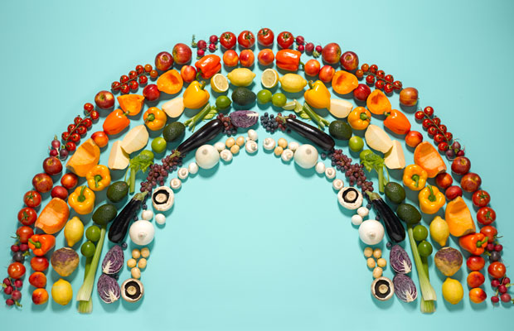 | Technical knowledge  - I know what makes a balanced diet.  - I can find the nutritional information on packaging.  - I can identify the five main food groups.  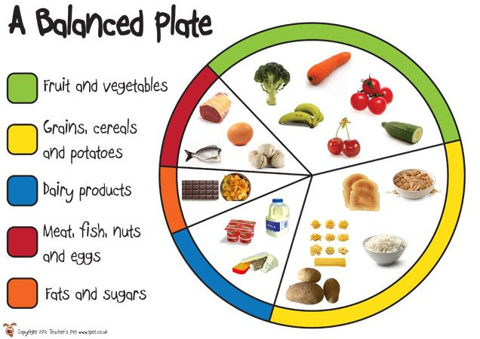
NUSERY- making playdough throughout the year. Bread making project  Children will have the opportunity to taste a range of foods and decide on foods that would be suitable for an event like a picnic. They will use tools confidently to make sandwiches, fruit kebabs, porridge toppings, and biscuits for the picnic.  They will have the opportunity to design and make their own gingerbread person, thinking about foods that would help them to create its features.  Children have frequent opportunities in preparing food for their snack time and feeding their pet guinea pigs.  Lesson 1:  Q: What is a fruit and what is a vegetable?  Builds on: Fruit that we eat at snack time  Intent: LO To identify foods that are healthy for our bodies.  Implementation: Workshop with Chatwells. Name and taste a range of different fruits and vegetables. Make a picture from The Hungry Caterpillar using the different fruits and vegetables. How do they taste?  Future learning: Understanding how different fruits and vegetables grow | Lesson 1: Q; Is a tomato a fruit or vegetable?  Builds on: EYFS awareness of different types of fruit and vegetables  Intent: L.O: To identify the difference between fruits and vegetables.  Implementation: See detailed Kapow planning  Future learning: Do fruits and vegetables taste different?  Lesson 2: Q; Do all things grow in the same way?  Builds on: EYFS-understanding of where some fruits/vegetables grow  Intent: L.O: To understand where fruits and vegetables grow.  Implementation: See detailed Kapow planning  Future learning: growing fruits and vegetables and watching how they grow.  Lesson 3: Q; What’s your favourite thing to eat?  Builds on: EYFS- trying a range of foods throughout the year  Intent: L.O: To investigate tastes and textures.  Implementation: See detailed Kapow planning  Future learning: Dream meal- group of foods together  Lesson 4: Q;  Builds on: Using equipment in EYFS  Intent: L.O: To make a delicious smoothie.  Implementation: See detailed Kapow planning  Future learning: What other healthy meals can you make? | Lesson 1: Q; What’s your dream meal?  Builds on: Yr 1-Food groups  Intent: L.O: To know what makes a balanced meal.  Implementation: See detailed Kapow planning  Future learning: How can you can your meal have different aspects from the food wheel.  Lesson 2: Q; What’s your favourite taste?  (sweet, salty, spicy, strong, mild)  Builds on: Yr1-Investigating tastes and textures  Intent: L.O: To taste test food combinations.  Implementation: See detailed Kapow planning  Future learning: What foods taste good together?  Lesson 3: Q; Where do we get our energy from?  Builds on: Yr1-Smoothie making  Intent: L.O: To design a healthy wrap.  Implementation: See detailed Kapow planning  Future learning: understanding what a healthy meal looks like.  Lesson 4: Q; What is the weirdest thing you’ve ever eaten? (Kidz v Food Clip?)  Builds on: Lesson 1- Balanced healthy meal  Intent: L.O: To make and taste evaluate a healthy wrap.  Implementation: See detailed Kapow planning  Future learning: Designing a meal for a target audience. How can it be improved?

EYFS -Joining techniques | YEAR 1-Mechanisms-Wheels& Axles | YEAR 2-Mechanisms-Ferris Wheel
Technical knowledge  - I can handle tools and materials safely.  - I can use simple tools to effect changes in materials.  - I explore a range of materials, tools and techniques.  - I can construct with a purpose in mind using a range of resources.  - I can select tools and techniques in order to assemble and join materials.  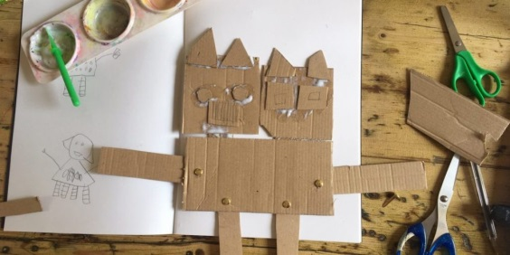 | Technical knowledge  - I understand that levers and sliders are mechanisms that make things move.  - I can identify whether a mechanism is a lever or slider and determine the movement it makes.  - I can use the vocab: up, down, left, right, vertical and horizontal to describe movement.  - I can identify how a mechanism moves forward.  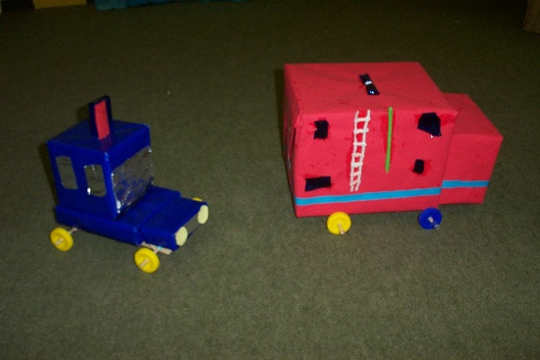  - I know that a wheel needs to be attached to an axle to move. | Technical knowledge  - I know that a mechanism is a collection of moving parts working together in a machine.  - I know that mechanisms have inputs and outputs.  - I can identify a mechanism in everyday objects.  - I know that levers turn on a pivot.  - I can describe ‘linkage’ as a system of levers connected by pivots.  - I can explain how axels help wheels to move.  - I can explore wheels as mechanisms.  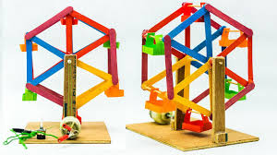
NURSERY- Learning different joining techniques- hole punches introduced and l-brace technique taught  Children will learn how to join materials together in different ways, exploring how some ways of joining allow the parts to move. These ways include, chain links, l-braces, tabs, flange technique, split pins, hole punching and slot technique. They will apply this knowledge in order to create products with moving parts throughout the year, linked to the Talk for Writing texts and their interests.  Children explore different mechanisms throughout the year. We look at how toys move like windmills, spinners, springs and pull back vehicles. Children are encouraged to explore and transfer these concept ideas to their own learning in construction and art areas.  Children will develop a range of fine motor skills in order to move and manipulate items in different ways. | Lesson 1: Q; How do things move?  Builds on: EYFS- exploration of joining techniques. Exposure to cars, bikes and other items with moving wheels.  Intent: L.O: To investigate how wheels move on a vehicle.  Implementation: See detailed Kapow planning  Future learning: What a chassis is. How more than one wheel can move at once.  Lesson 2: Q; What is a chassis?  Builds on: How wheels move by themselves, looking at different mechanisms.  Intent: L.O: To explore how to fix and attach wheels to a vehicle.  Implementation: See detailed Kapow planning  Future learning: Do all vehicles have a chassis?  Lesson 3: Q; If you were a postman, what would your van look like?  Builds on: EYFS designing and planning to create a plan  Intent: L.O: To design a new postal service van.  Implementation: See detailed Kapow planning  Future learning: Following a plan  Lesson 4: Q; How will we know if our designs are successful?  Builds on: EYFS: Evaluating and talking about what went well and what can be improved.  Intent: L.O: To build and test my design.  Implementation: See detailed Kapow planning  Future learning: Sharing and being able to constructively critique their own and others work. | Lesson 1: Q; What is your favourite fairground ride?  Builds on: EYFS & Yr1-Recap on how wheels move.  Intent: L.O: To explore wheel mechanisms and design a wheel.  Implementation: See detailed Kapow planning  Future learning: Lesson 2  Lesson 2: Q; What can we remember about materials from science to help us today?  Builds on: Yr1-How wheels and axels work  Intent: L.O: To select appropriate materials for my wheel.  Implementation: See detailed Kapow planning  Future learning: Lesson 3  Lesson 3: Q; How are we going to make our wheels stable?  Builds on: Understanding of a chassis.  Intent: L.O: To build and test a moving wheel.  Implementation: See detailed Kapow planning  Future learning: Enable successful build in lesson 4  Lesson 4: Q;  Builds on: Yr1-Making a moving vehicle  Intent: L.O: To make and evaluate a structure with a rotating wheel.  Implementation: See detailed Kapow planning  Future learning: choosing a suitable mechanism for your project- having a choice from previous taught skills.

EYFS | YEAR 1-Mechanisms-Moving Story Books | YEAR 2-Mechanisms-Moving Monsters
Technical knowledge  - I can handle tools and materials safely.  - I can use simple tools to effect changes in materials.  - I explore a range of materials, tools and techniques.  - I can construct with a purpose in mind using a range of resources.  - I can select tools and techniques in order to assemble and join materials. | Technical knowledge  - I understand that levers and sliders are mechanisms that make things move.  - I can identify whether a mechanism is a lever or slider and determine the movement it makes.  - I can use the vocab: up, down, left, right, vertical and horizontal to describe movement.  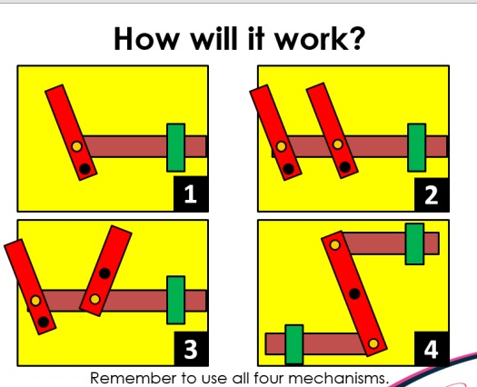 | Technical knowledge  - I know that a mechanism is a collection of moving parts working together in a machine.  - I know that mechanisms have inputs and outputs.  - I can identify a mechanism in everyday objects.  - I know that levers turn on a pivot.  - I can describe ‘linkage’ as a system of levers connected by pivots.  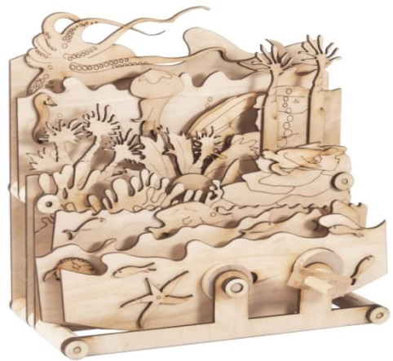
Explicit lesson- how to make a simple moving picture from a story.  Lesson 1- Q What is your favourite story?  Builds on: exploration of junk modelling  Intent: LO: TO understand a simple mechanism  Implementation: Children to choose a favourite page from a book of their choice. Make a stick puppet of a character from the book. Children have a go at using scissors to create a cut in the book scene so their character can move from side to side.  Future learning: Year 1 mechanisms | Lesson 1: Q; Can you show me a natural lever in your body? (Bent arm levers are identified by the way the joint and muscles attached to the bone.)  Builds on: EYFS- exploration of toys that move in different and varied ways.  Intent: L.O: To understand how mechanisms move using sliders.  Implementation: See detailed Kapow planning  Future learning: Using what they know and implementing it in a design  Lesson 2: Q; If you could make a moving picture, what would it look like?  Builds on: using joining techniques to make models and pictures  Intent: L.O: To design and plan my story book.  Implementation: See detailed Kapow planning  Future learning: Using linkages and pivots  Lesson 3: Q; What will we need to succeed today?  Builds on: EYFS: Fine motor skills to build and manipulate their ideas. Creativity from exploration  Intent: L.O: To construct my chosen design.  Implementation: See detailed Kapow planning  Future learning: What could be improved? Does this design meet the expectation for your target audience?  Lesson 4: Q; Who can we share our moving books with?  Builds on: EYFS: Building for a purpose- for themselves or a family member.  Intent: L.O: To test and evaluate my design with a reception child.(Target audience)  Implementation: See detailed Kapow planning  Future learning: Planning and making for an intended audience. | Lesson 1: Q; How many different types of movements can you show me?  Builds on: To understand how mechanisms move using sliders.  Intent: L.O: To know that mechanisms can move using pivots and linkage systems.  Implementation: See detailed Kapow planning  Future learning: Lesson 2-Moving monster project.  Lesson 2: Q; What does a sea monster look like and can you show me how it moves?  Builds on: Yr1-Creating a moving book using a slider.  Intent: L.O: To design a moving sea monster.  Implementation: See detailed Kapow planning  Future learning: To create using multiple taught linkage skills within one project.  Lesson 3: Q; Can we make human linkage systems in groups?  Builds on: Yr 1- Following a plan to move an element of a card.  Intent: L.O: To make my own linkages using card for levers and split pins for pivots.  Implementation: See detailed Kapow planning  Future learning:To be able to move or pick something up.  Lesson 4: Q; What do we want from our sea monsters?  Builds on: making for a target audience or specific purpose.  Intent: L.O: To construct and assemble a moving sea monster  Implementation: See detailed Kapow planning  Future learning: Sharing and evaluating across the school.

EYFS-Boats | YEAR 1-Structures-Windmills | YEAR 2-Structures-Chair
Technical knowledge  - I can handle tools and materials safely.  - I can use simple tools to effect changes in materials.  - I explore a range of materials, tools and techniques.  - I can construct with a purpose in mind using a range of resources.  - I can select tools and techniques in order to assemble and join materials. | Technical knowledge  - I can describe the purpose of different structures.  - I can turn a 2D net into 3D structures.  - I can change the shape of materials to improve the strength and stiffness of structures.  - I know that cylinders are strong structures used for stability in windmills and lighthouses.  - I can explain how a blades on a wind turbine uses wind to turn to work.  - I can identify how axels are used in structures and mechanisms to make parts move in a circle.  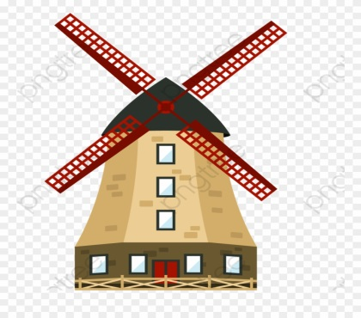 | Technical knowledge  - I can identify man-made and natural structures.  - I can identify structures that are stable and unstable.  - I understand that structures with a flat, wide base is more stable.  - I know that the shape of a structure affects its strength.  - I can use the vocabulary: strength, stiffness and stability.  - I can manipulate materials to improve strength and stiffness of structures.  - I can build a strong and stiff structure by folding paper.  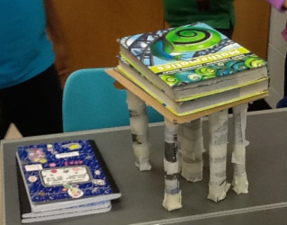
NURSERY- big build of clock tower in Redruth-  Reception  Lesson 1: How can The Gingerbread Man cross the river?  Builds on: Exploration of junk modelling and construction in provision  Intent: LO: To create a structure that crosses water.  Implementation: Discuss different structures we know. Create a diagram of all the structures we found out about. Ch choose the structure they would like to make- draw their design. Choose how they would like to make it- art/construction/role play classrooms and outside. Ch share and talk about what they would improve next time. Is your structure stable for TGM to cross?  Future learning: Can you make your structure stable? How can you achieve this?  Other projects explored rockets, boats and mining tools  Lesson 2: Make a boat for Mr Gumpy  Builds on: A solid structure that crosses the river  Intent: LO: To design and make a waterproof boat that floats.  Implementation: look at a range of different boats. Learn 4 parts of the boat, ‘hull, deck, mast and sail’  Design a boat and ensure you have each part.  Testing out materials- does Mr Gumpy stay dry? Would it be a good material for your boat?  Make- look at materials and choose which bit would be a good mast, hull, deck and sail. Waterproof boat using chosen material. Testing boats.  Future learning: How can you reinforce your structure | Lesson 1: Q; What can you see?(Turbine pics)  Builds on: EYFS: Understanding of different structures  Intent: L.O: To make a design criteria and a design template.  Implementation: See detailed Kapow planning scheme.  Future learning: lesson 2  Lesson 2: Q; What makes a structure strong?  Builds on: EYFS: Building and experimenting with different structures. Which structure can stay stable?  Intent: L.O: To construct a strong & stable structure.  Implementation: See detailed Kapow planning scheme.  Future learning: How can you make flimsy materials strong?  Lesson 3: Q; What energy source fuels a windmill or wind turbine?  Builds on: EYFS: Awareness of wind, water and heat.  Intent: L.O: To create blades on a windmill and test they rotate on an axis.  Implementation: See detailed Kapow planning scheme.  Future learning: What is the best material to ensure they work correctly?  Lesson 4: Q; What top tips would you give to create another windmill?  Builds on: EYFS: Adapting their designs.  Intent: L.O: To evaluate and adapt our designs.  Implementation: See detailed Kapow planning scheme.  Future learning: Children can easily identify areas for improvement and know how to adapt their ideas. | Lesson 1: Q; What do we know about structures?  Builds on: Yr1-Creating strong & stable structures.  Intent: L.O: To investigate and compare the stability of 3D shapes.  Implementation: See detailed Kapow planning scheme.  Future learning: Lesson 2  Lesson 2: Q; What are the features of a good chair?  Builds on: Understanding of strong materials.  Intent: L.O: To explore ways of making paper strong.  Implementation: See detailed Kapow planning scheme.  Future learning: Lesson 3-Making a chair  Lesson 3: Q; What is our design criteria?  Builds on: Yr1 &Yr2-Building structures and exploring how they can be made; strong, stiff and stable.  Intent: L.O: To make a chair structure using design.  Implementation: See detailed Kapow planning scheme.  Future learning: How much weight can a structure take? What do you think is the strongest?  Lesson 4: Q;  Builds on: Yr1- To evaluate and adapt our designs.  Intent: L.O: To adapt and improve my chair through testing.  Implementation: See detailed Kapow planning scheme.  Future learning: understanding what they can do to enhance stability next time.

EYFS- Textiles - Clothing | YEAR 1-Textiles-Puppets | YEAR 2-Textiles-Pouches
Technical knowledge  - I can handle tools and materials safely.  - I can use simple tools to effect changes in materials.  - I explore a range of materials, tools and techniques.  - I can construct with a purpose in mind using a range of resources.  - I can select tools and techniques in order to assemble and join materials.  I can manipulate materials to create a planned effect.  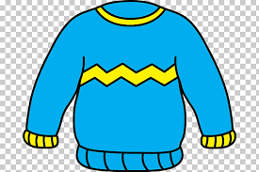 | Technical knowledge  - I can join fabrics together in different ways: pinning, stapling and gluing.  - I can sew a basic running stitch using a guide.  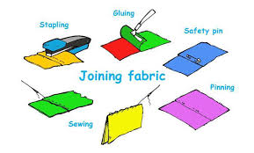 | Technical knowledge  - I can join items together using glue or stitching.  - I can identify the best technique for the task.  - I can thread a needle.  - I can use a running stitch that is evenly spaced and neat to join fabric.  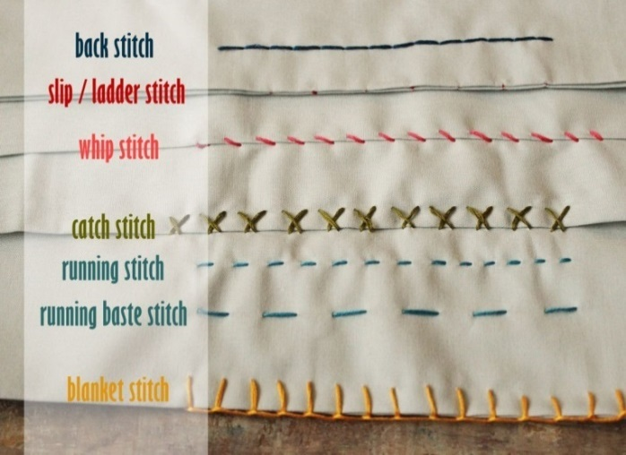  - I can have a go at another stitch if appropriate for my project.
NURSERY- textile table explored throughout provision  Children will explore a range of textiles and materials, looking at uses, purposes and suitability for purpose. They will think about clothing for a purpose and select materials that can be used to create clothing to wear in different environments. They will experiment with ways in which these materials can be joined securely. They will learn how to thread beads onto a piece of rope/pipe cleaners before learning how to thread a large eyed needle. Sewing opportunities will be available throughout the year. They will be able to design, make and evaluate their design and share their opinions about it. Children will explore different materials and which material is most suitable for their projects.  Lesson 1: What is your favourite animal?  Builds on: Art area exploration- how can you embellish your creation?  Intent: LO: Create a fabric badge  Implementation: Design and create fabric badge using joining techniques (glue, sellotape and staples)  Future learning: Learning about different joining techniques in junk modelling area- hole punches and flange. In provision enhancements and planned continuous provision. | Lesson 1: Q; How are our toys and clothes held together without falling apart?  Builds on: EYFS: joining techniques explored.  Intent: L.O: To explore how fabrics are joined in different ways.  Implementation: See detailed Kapow planning scheme.  Future learning: What different stitches look like and what are more effective.  Lesson 2: Q; What does your favourite story book character look like?(Link to characterization)  Builds on: EYFS: designing for an outcome.  Intent: L.O: To use a template to create my own puppet design.  Implementation: See detailed Kapow planning scheme.  Future learning: Create for a purpose or person  Lesson 3: Q; What are the different ways of joining materials together?(properties of materials)  Builds on: EYFS: Exploration through materials and joining techniques.  Intent: L.O: To join my puppet fabric together using a chosen technique.  Implementation: See detailed Kapow planning scheme.  Future learning: To sew using a running stitch  Lesson 4: Q; What did we learn from making our puppets?  Builds on: EYFS: evaluating and discussing our projects  Intent: L.O: To evaluate my puppet against a given design criteria.  Implementation: See detailed Kapow planning scheme.  Future learning: Talking to target market about their creations, does it fit a brief. | Lesson 1: Q; Can you spot something that has been sewn together in our room?  Builds on: Yr 1- How fabrics are joined in different ways.  Intent: L.O: To sew a running stitch. (practising skills- hole punched paper)  Implementation: See detailed Kapow planning scheme.  Future learning: independently be able to stich fabric together.  Lesson 2: Q; What could we create for Hansel & Gretel to carry their pebbles?  Builds on: Yr 1-Using a given design template.  Intent: L.O: To design a magic pouch to carry something in.  Implementation: See detailed Kapow planning scheme.  Future learning: making their pouch  Lesson 3: Q; How do we want our stitching to look? (Look at good/bad examples of running stitch)  Builds on: yr 1- exploration of a running stitch.  Intent: L.O: To make a pouch using running stitch to join fabric.  Implementation: See detailed Kapow planning scheme.  Future learning: Improving a part of project- redoing a stitch  Lesson 4: Q; What could we use to embellish our pouches? (Explain finishing techniques)  Builds on: yr1-Gluing, sticking fixing techniques  Intent: L.O: To evaluate and test pouch for its purpose.  Implementation: See detailed Kapow planning scheme.  Future learning: building repertoire of stitches they can use.

