Phonics Screening Check 2022

Dear Parents and Carers,
I am writing to inform you about the National Phonics Screening Check, which will take place in the second half of the Summer term for all children in Year 1.
What is the Phonics Screening Check?
The phonics screening check is designed to confirm whether individual children have learnt sufficient phonic decoding and blending skills to an appropriate standard.
What Happens During the Test?
The test contains 40 words. Each child will sit one to one and read each word aloud to a teacher. The test will take approximately 10 minutes per child, although all children are different and will complete the check at their own pace. The list of words the children read is a combination of 20 real words and 20 pseudo words (nonsense words).
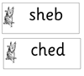

Examples of Pseudo Words (Nonsense words)
The pseudo words will be shown to your child with a picture of an alien. This provides the children with a context for the pseudo word which is independent from any existing vocabulary they may have. Pseudo words are included because they will be new to all pupils; they do not favour children with a good vocabulary knowledge or visual memory of words.
Reporting to Parents
All schools must report their child’s results to parents. They will also confirm if the child has met the standard threshold. Children who do not achieve the expected level will have the opportunity to retake the test whilst they are in Year 2.
Preparation for the test
Children have daily phonics lessons throughout EYFS and in Year 1 and 2. This teaches children to become confident readers and prepares them for the screening check. Children also have extra practice times for speed sounds and decoding words. When reading, children firstly spot ‘special friends.’ These are sounds that have two or more letters e.g. ay, igh, and split ‘e.’
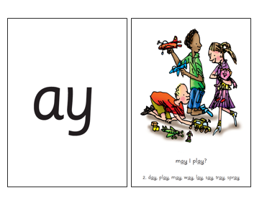

Example of a speed sound card showing special friends ‘ay.’

Children are taught to decode real and pseudo words by sounding out and blending. This includes multi-syllabic words e.g. midnight, sandwich, bedroom. Children learn to segment words first before sounding out and blending.

How Can I Help My Child At Home?
- Read as much as possible to and with your child.
- If your child is struggling to decode a word, help them by encouraging them to say each sound in the word from left to right. ‘Spot special friends, Fred-talk, read the word.’
- Blend the sounds by pointing to each letter, e.g. /c/ in cat, or the letter group, e.g. /ng in sing. Next move your finger under the whole word as you say it.
- Play games on Phonics Play to encourage the children to read the words and sort them into real/not real – Obb and Bob, the Dragon game and Buried Treasure are perfect for this.
- Visit the Ruth Miskin Parents’ Page:
http://www.ruthmiskin.com/en/parents
Ruth Miskin Facebook: https://www.facebook.com/miskin.education

If you have any further questions please do not hesitate to contact me.

Kind Regards
Mrs Montgomery-Smith
Reading Lead

