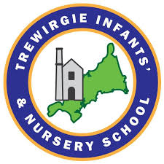
Music Progression of Skills

OUR VISION FOR TREWIRGIE INFANTS’SCHOOL
‘We care, we help, we succeed’

OUR MISSION:
- To inspire children to engage in learning, and be valued members of a caring, supportive, and successful school.
- For all our children to develop life-long learning skills; to be independent and creative thinkers and to be socially confident.
- To enable children to be successful through a curriculum that captures their interests, stimulates their ideas, encourages inquisitiveness and critical thinking and meets their needs.

At Trewirgie Infants’ School we believe that Music is an essential part of life, integral in the development of the whole person. Our school gives our children the opportunity to engage in musical experiences which we believe is crucial for the development of the whole child and we aim to give children a lifelong love of music. Engaging in music supports the development of all aspects of a child’s learning, from the physical action of using an instrument and the mathematical skills needed to keep a pulse beat, to the listening to the wide variety of sounds created by both voice and instruments. These abilities are directly transferable to other areas of the curriculum, allowing them to flourish, and will be invaluable in their future life. At our school, children have access to music through regular classroom activities and formal music lessons. Our school uses “Sparkyard” to support the learning of each strand of the Music curriculum.

INTENT  (curriculum design, coverage and appropriateness) | IMPLEMENTATION  (curriculum delivery, teaching and assessment) | IMPACT  (attainment and progress)
At Trewirgie Infants’ School we believe music is inclusive and accessible to all. We want children to develop a lasting love of music through being exposed to different genres, composers, and styles of music through high quality examples that are performed through live experiences or technology.  Trewirgie Infant & Nursery School use ‘Sparkyard’ to deliver music lessons. Music lessons are interactive and engaging for children and are structured so that non-specialist teachers are able to teach high quality music lessons. Throughout the lessons, children develop their listening and appraising skills as well as developing their musical vocabulary. Alongside developing their singing and playing skills, children develop their improvisation and composition skills. Children are encouraged to take part in activities and perform as part of a group and have regular access to un-tuned and tuned instruments. As part of the sequence of lessons, children’s learning is recorded through writing down quotes, filming performances and recording their improvisations. | All children within the school will have access to structured music lessons with access to un-tuned and tuned instruments. We follow the Sparkyard Music Curriculum. It uses a skills-based approach where key musical concepts and themes are developed and revisited across the year groups, building on knowledge and understanding at every stage. Pupils have regular opportunities to perform at the end of each unit taught. Children will have opportunities to perform at assemblies, Christmas productions and end of year shows in year 2. The curriculum map outlines the progression of skills throughout the school and builds on previous knowledge. Children will also be exposed to musical terminology, such as pitch, rhythm and beat.  Our curriculum map shows the skills progression throughout the school with planning that builds on previous knowledge and skills to ensure each child progresses during their time with us from their various starting points. Year group planning is allowing children to gain knowledge, master skills, plan, prepare and perform. | At Trewirgie our children show a love of music in various forms, from EYFS pupils using their stage to perform to their peers in the playground to Key Stage 1 children singing skipping rhymes and current popular songs during their playtimes. Each child has the desire to listen to and to perform music whilst being inspired and curious about different genres of music.  Pupil conferencing shows children are happy, engaged, creative, enthusiastic, and motivated to do well and are challenged.  Learning walks by subject leader, senior leadership team, governors, or external visitors shows evidence of our intent in action and progress.  Evidence of learning is shown with photographs, video and recordings alongside planning and end of unit assessments.  Children will have an appreciation of how music can contribute to mood, relaxation, mental health, and wellbeing. High quality performances are shared with fellow pupils in assemblies and classes and with parents during termly presentations.

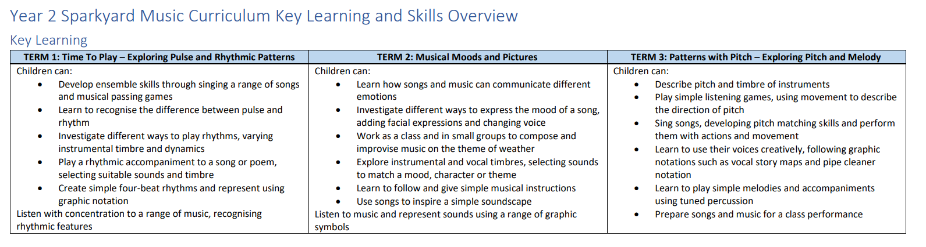
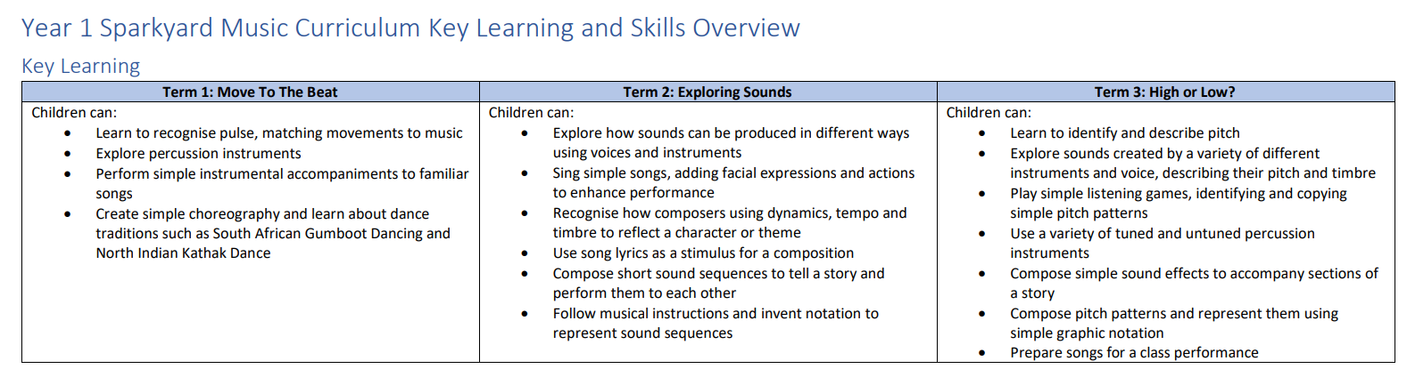

Autumn | Term 1: My Musical Classroom  Unit overview  Intent: The children will learn simple welcome songs and have fun working as a class to create simple actions to accompany songs and nursery rhymes. They will learn to follow musical instructions and explore creative movement – jumping like a jack-in-the-box or dancing like a rock ’n’ roll teddy bear!  Implementation: Active listening activities are used throughout the term and the children will experience a range of music from West African dance to the sound of Norwegian ice instruments! As the term progresses, they will learn to recognize simple classroom percussion instruments and compare their sounds. They will compose simple sound sequences and represent them using objects and pictures.  See detailed Sparkyard planning.  Progression of the lessons:  Step 1 – Hear my voice  Step 2 – What’s the music saying?  Step 3 – Instruments everywhere  Step 4 – Playing with songs  Future learning: This unit builds onto the Year 1 unit. ‘Move to the beat – Exploring pulse and rhythm’.  Christmas Production-Performing  Term 2: Musical patterns and performing  Unit overview  Intent: This term begins with activities designed to get children recognizing musical patterns in songs and music.  Implementation: They will add actions to match song lyrics, play listening games to develop recall of sound sequences, and have fun exploring music-and-movement patterns through songs such as The Mouse And The Giant.  The children will develop their recognition of classroom percussion instruments, using them to play simple accompaniments and simple rhythm patterns. They will also begin to explore ways to change sounds and create simple patterns, e.g. playing loudly, quietly, slowly or quickly.  Composing music inspired by transport, machines and robots provides an opportunity to explore descriptive sounds and to develop an understanding of pictorial notations.  See detailed Sparkyard planning.  Progression of the lessons:  Step 1 – What’s the pattern?  Step 2 – Playing musical patterns and accompaniments  Step 3 – Exploring descriptive sounds  Step 4 – Let’s perform!  Future learning: This unit builds onto the Year 1 unit. ‘Exploring Sounds.’ | Term 1 - Move to the beat – Exploring pulse and rhythm  This unit builds on the Reception unit ‘My Musical Classroom’  Unit overview  Intent: This term, the children will learn to recognize pulse, matching movements to music. They will explore percussion instruments and perform simple instrumental accompaniments to familiar songs.  Implementation:  The children will progress to copying and creating simple rhythm patterns, eventually using simple graphic notations to represent these sounds. Throughout the term, they will be introduced to a range of music and create simple choreography for music, as well as learning about different dance traditions.  See detailed Sparkyard planning.  Progression of the lessons:  Step 1 - Exploring pulse through songs and movement  Step 2 - . Controlling pulse using voices and instruments  Step 3 - Exploring the difference between pulse and rhythm  Step 4 - Copying and creating rhythmic patterns.  Future learning: This unit builds onto the Year 2 unit. ‘Time to play – exploring pulse and rhythmic patterns’.  Christmas Production-Performing  Term 2: Exploring Sounds  This unit builds on the Reception unit ‘Musical Patterns and Performing.  Unit overview  Intent: This term, the children will be exploring how sounds can be produced in different ways using voices and instruments.  Implementation: They will listen to a variety of music and will begin to recognize how composers use dynamics, tempo and timbre to bring a character or theme to life! They will learn to sing simple songs as a class, adding facial expressions and actions to enhance a performance. The children will explore song lyrics and use these as a basis for their own compositions. Working as a class and in small groups, they will compose short sound sequences to tell a story or reflect a character and perform these to each other. They will learn to follow musical instructions and invent their own musical notation to represent a sequence of sounds.  Progression of the lessons:  Step 1 - Exploring how sounds can be changed  Step 2 - Exploring the timbre of instruments and voices  Step 3 - Sequencing sounds to tell stories and create effects  Step 4 – Using graphic notation to represent sounds  Future learning: This unit builds onto the Year 2 unit. ‘Music Moods and Pictures’. | Term 1: Time to play – exploring pulse and rhythmic patterns  This unit builds on the Y1 unit ‘Move to the beat – exploring pulse and rhythm’  Unit overview  Intent: From body percussion to disco music, this term develops children’s understanding of pulse and rhythm.  Implementation: The term begins with songs and activities to get children performing together rhythmically. The children will perform actions and movements to a steady pulse and play simple musical passing games. They will learn songs to explore the difference between pulse and rhythm, and investigate different ways to play rhythms, varying instrumental timbre and dynamics.  Working as a class and in small groups, the children will learn to play a simple accompaniment to a song or poem, selecting suitable sounds and timbre. They will learn to create simple four-beat rhythms and represent these using graphic notations such as Beat Monsters!  See detailed Sparkyard planning.  Progression of the lessons:  Step 1 – Performing rhythms and movement to a steady pulse  Step 2 – Copying and creating rhythmic patterns  Step 3 – Combining rhythmic patterns  Step 4 - Representing rhythmic patterns  Future learning: This unit builds onto the Year 3 unit. ‘Hear it, play it! Exploring rhythmic patterns.’  Christmas Production-Performing  Term 2: Musical moods and pictures  This unit builds on the Y1 unit ‘Exploring Sounds’  Unit overview  Intent: This term, the children will learn how songs and music can communicate different moods and emotions.  Implementation: They will investigate different ways to express the mood of a song by adding facial expressions and changing the timbre and dynamics of their voice. They will develop their understanding of musical mood through simple songs, where they will be introduced to major and minor tonality.  Throughout the term, the children will listen and talk about a wide variety of music. They will learn to represent the sounds they hear using graphic symbols and musical doodles!  Working as a class and in small groups, they will compose and improvise music on the theme of weather. They will learn to give musical instructions, taking the role of a conductor in a small group performance. They will create descriptive sounds inspired by a song and create a simple soundscape.  See detailed Sparkyard planning.  Progression of the lessons:  Step 1 - Recognizing and exploring musical mood  Step 2 - Choosing sounds to match a character, mood or theme  Step 3 - Sequencing and combining sounds to tell stories and create effects  Step 4 - Creating and performing soundscapes  Future learning: This unit builds onto the Year 3 unit. ‘Painting pictures with sound.’
Summer | Term 3: Sound Stories  Unit overview  Intent: Heading outdoors is encouraged with musical storytelling inspired by the natural environment. From sound sticks to journey sticks, the children will learn to create musical patterns, using natural objects as a musical score.  Implementation: The children will learn to create musical patterns, using natural objects as a musical score. Listening choices also reflect the outdoors theme – the perfect opportunity to learn about instruments made from wood. An introduction to musical timbre is explored through fairy-tale characters as the children learn to associate characters with instruments. They will explore the effect of layering instrumental sounds, developing an understanding of musical texture. The story theme continues as children learn to use simple sound effects and pictorial notation to accompany a story or song.  See detailed Sparkyard planning.  Progression of the lessons:  Step 1 – Pitch play and changing sounds  Step 2 – Sounds from nature: Patterns and sequences  Step 3 – Meet the characters  Step 4 – Perform a story!  Future learning: This unit builds onto the Year 1 unit. ‘: ‘High and low – exploring pitch’ | Term 3: High and low – exploring pitch  This unit builds on the Reception unit ‘Sound Stories.’  Unit overview  Intent: This term, the children will be identifying and describing pitch.  Implementation:  The children will explore the sounds created by a variety of different instruments and voices, describing their pitch and timbre. They will play simple listening games and identify simple pitch patterns in a range of songs and music, recognizing when the pitch gets higher or lower. They will use a variety of tuned and untuned percussion instruments and compose simple sound effects to accompany sections of a story. They will compose pitch patterns and represent these using creative graphic notation tools such as pipe cleaners and coloured cubes! They will finish the term by preparing songs and music for a class performance.  See detailed Sparkyard planning.  Progression of the lessons:  Step 1 - Recognizing changes in pitch and copying simple pitch patterns  Step 2 - Performing simple melodic patterns using voices and pitched instruments  Step 3 - Representing pitch  Step 4 - Creating music for a performance  Future learning: This unit builds onto the Year 2 unit ‘Patterns with pitch – exploring pitch and melody.’ | Term 3: Patterns with pitch – exploring pitch and melody  This unit builds on the Y1 unit ‘High and low – exploring pitch’  Unit overview  Intent: This term, the children will be exploring pitch and melody. From the octobass to the piccolo, they will find out about a variety of instruments and learn to describe their pitch and timbre.  Implementation: They will play simple listening games and recall a pitch sequence, recognizing where the pitch gets higher, lower or stays the same. Through a range of songs, they will develop their pitch-matching skills, performing them with actions and movement. They will learn to use their voices creatively, creating sounds to match graphic notations such as vocal story maps and pipe-cleaner notation. They will play simple melodies using tuned percussion and be introduced to the pentatonic scale with songs such as Just Five Notes. They will finish the term by preparing songs and music for a class performance.  See detailed Sparkyard planning.  Progression of the lessons:  Step 1 – Identifying and describing changes in pitch  Step 2 – Copying pitch patterns  Step 3 – Creating and notating simple melodies  Step 4 - Performing simple musical accompaniments and preparing for performance  Future learning: This unit builds onto the Year 3 unit. ‘Sing, play, notate!’

