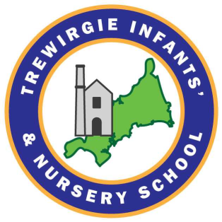

**Local Governing Board Members**

Cath Callow (Headteacher)

Kerry Raymond (Chair of Governors)

Emma Guppy-Wilcox (Vice Chair of Governors)

Nadine Francis

Holly Hipkins

Ian Eslick

Louise Pratley

Mike Hall

Lisa-Marie Clarke

**Governance Structure 2021-22**

**Finance and Audit**

Nadine Francis (Chair of Committee)

Cath Callow (Headteacher)

Kerry Raymond

Holly Hipkins

Ian Eslick

**Curriculum**

Emma Guppy-Wilcox (Chair of Committee)

Nadine Francis

Cath Callow (Headteacher)

Kerry Raymond

Lisa-Marie Clarke