Wild Tribe
A Guide for Parents
Look after yourself
Look after each other
Look after the environment
What benefits will my child get from participating in Wild Tribe?
Wild Tribe supports the holistic development of the child:
- Health and fitness – Being active in an outdoor, natural environment.
- Increased emotional wellbeing – There is research available supporting this.
- Social development – Communicating and negotiating with peers and adults to solve problems and share experiences.
- Skills development – Developing fine and gross motor skills and coordination for real purposes.
- Gaining knowledge and understanding – Multi–sensory, real-life learning.
- Individualised learning – Careful observation allows adults to tailor support to children’s own interests and stage of development.
- Curriculum Links – Wild Tribe supports many areas of the National Curriculum.

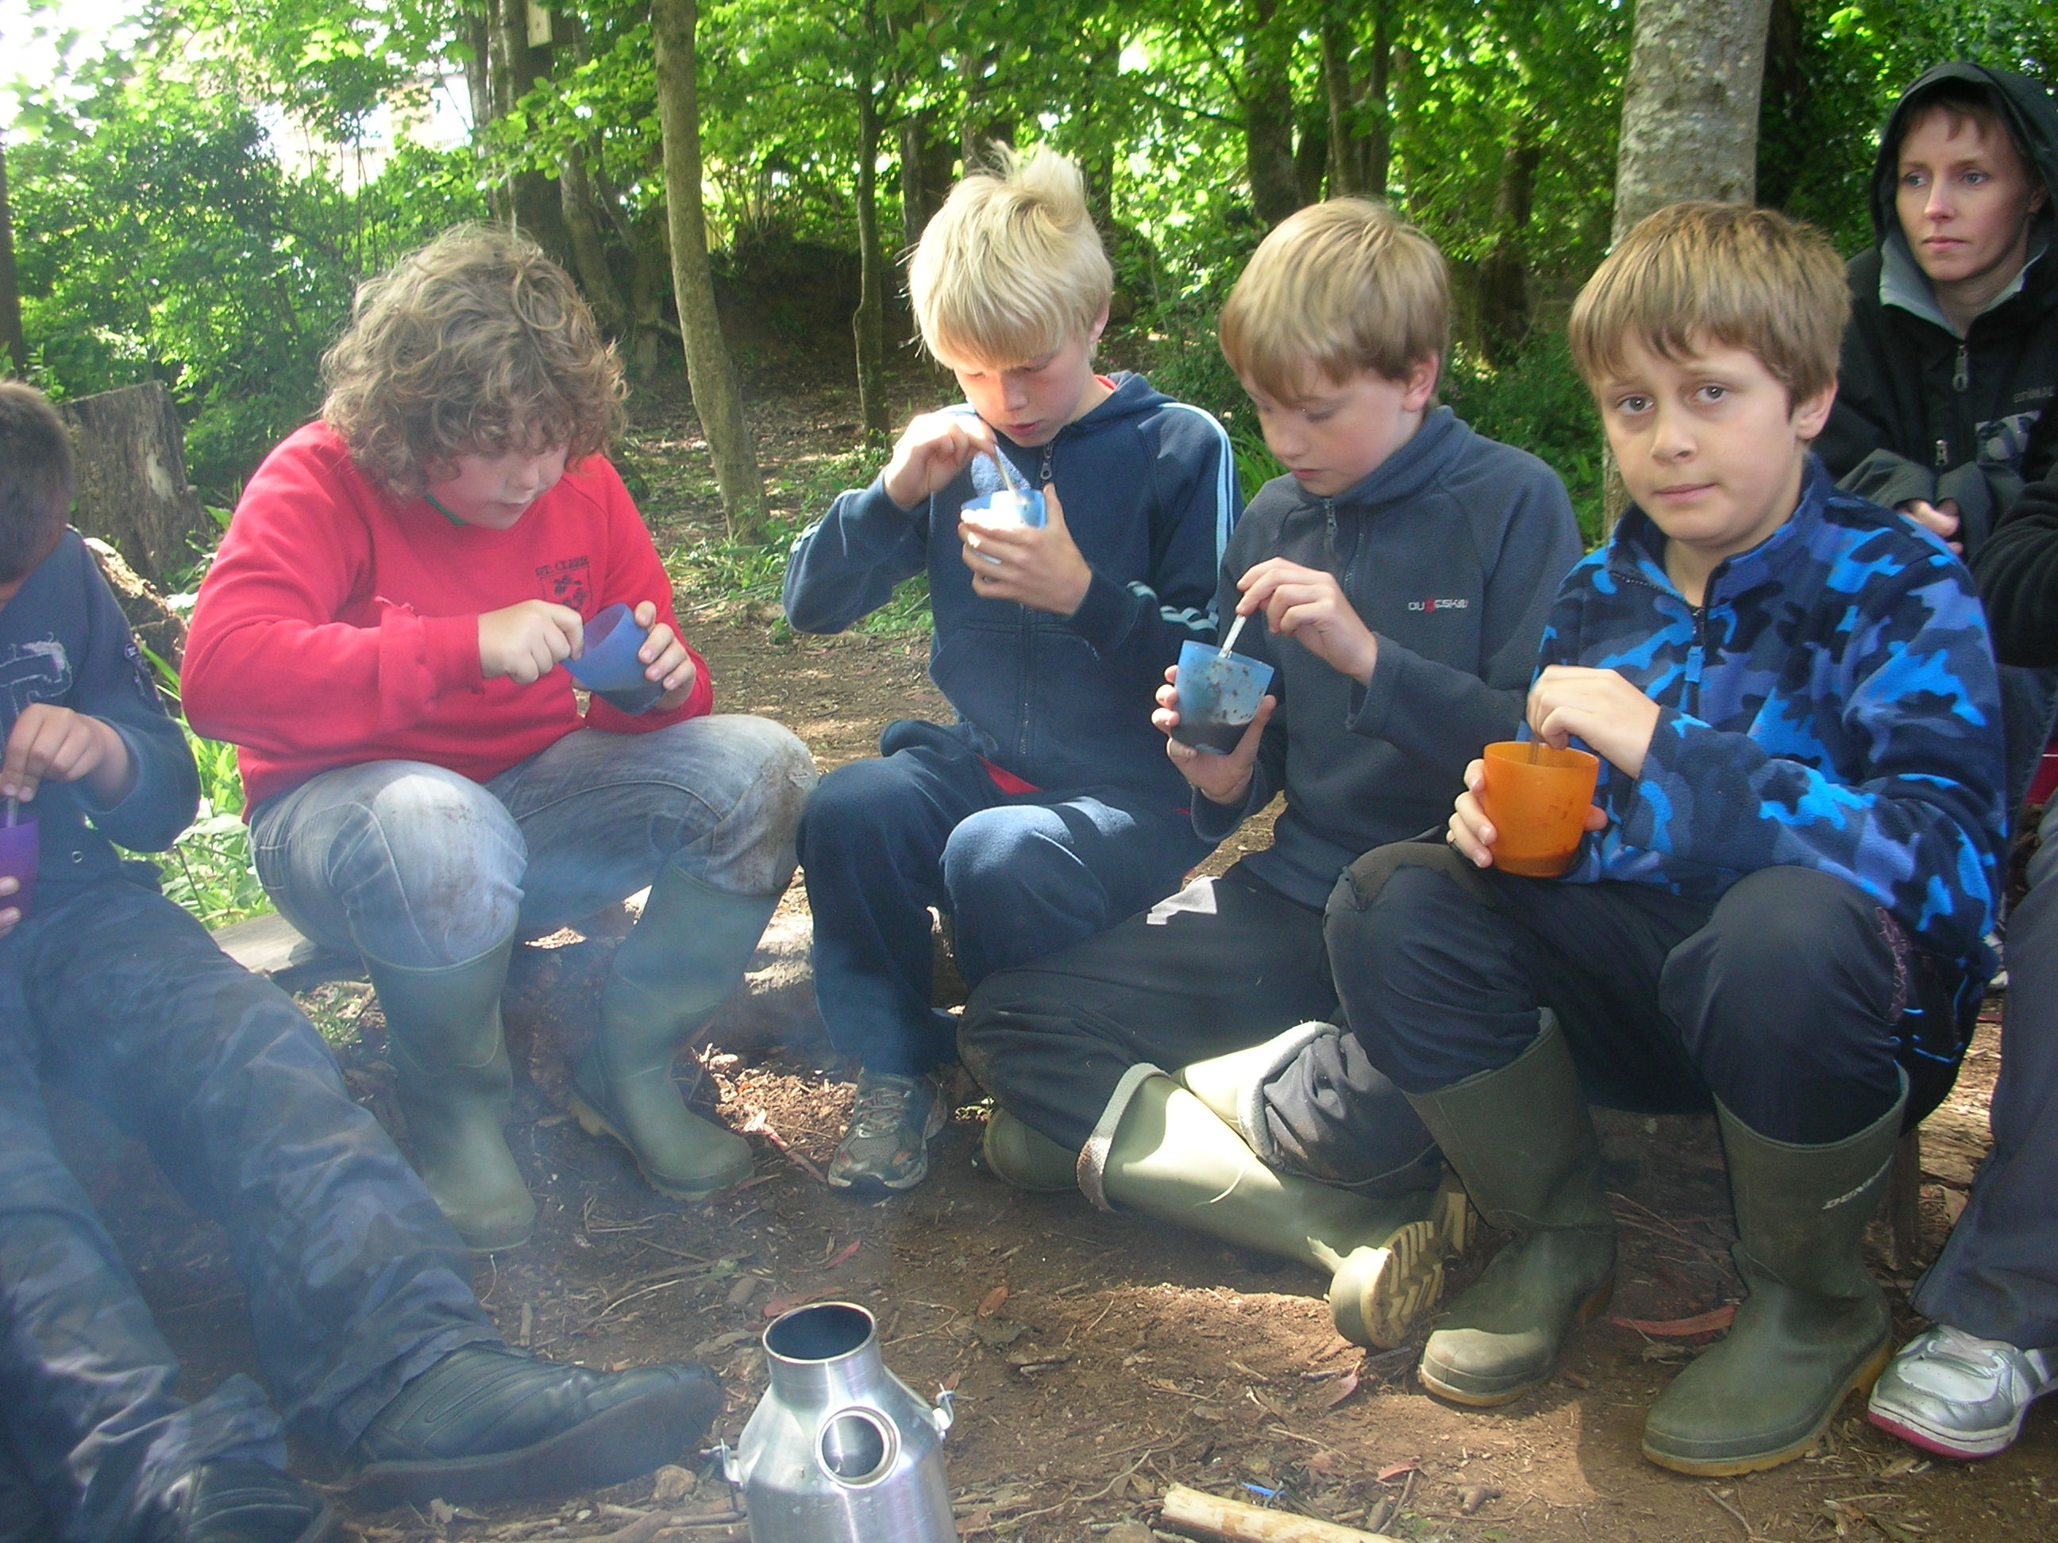

Health and Safety
The health and safety of all participants is central to everything done within a Wild Tribe programme. The Wild Tribe leader is fully trained in risk assessment and emergency outdoor first aid. Every Wild Tribe programme will have: a health and safety policy, a risk assessed site, risk assessments for activities, first aid and emergency equipment.

Some of the activities the pupils may participate in are ‘Higher risk activities (such as camp fire cooking and use of tools). However, these activities are not available to the pupils until certain behaviours and boundaries are established. Pupils are encouraged and supported in recognising and managing risk for themselves, through real life situations and experiences.

What does my child need to bring?
Your child just needs to bring themselves. However, what they wear is important. The children must wear long trousers and long sleeved tops and have waterproof jackets and wellies or old trainers. Please be aware that these clothes are likely to get dirty.
“This is the best kind of classroom,
It’s a journey through time and space,
From the smallest seed to the largest tree,
This is a Forest and a learning place.
This is the best kind of classroom,
Where the seasons don’t happen in books.
Where the learning is watching and thinking and talking
And everyone notices, everyone looks.”
From ‘The best Kind of Classroom’ by Ian MacMillan

What is Wild Tribe?
Wild Tribe has been based on the principles of Forest Schools which was developed from the Scandinavian education system and is about children and young people building self esteem and independence through exploring and experiencing the natural world. Wild Tribe is a long term programme delivered by trained practitioners within a natural environment (not necessarily a forest!)

Wild Tribe has been developed by teachers and practitioners working alongside each other to ensure that units of exploration have been developed, which meet the needs of all learners and meets the requirements of the National Curriculum.

Each Wild Tribe unit of exploration is tailored to meet the needs of individuals within that group and is continuously developed as the young people grow in confidence, skills and understanding as a result of their exploration.

The ethos of Wild Tribe allows learners the time and space to develop skills, interests and understanding through practical hands on experiences. It also allows practitioners to step back and observe the young people in order to then encourage and inspire individuals to achieve through careful scaffolding and facilitating. Wild Tribe has been developed based on the principles of Forest School but links much more with the curriculum.

Wild Tribe Leader:- Miss Nugent

What will my child be doing?
The Wild Tribe routine varies depending on the site, however it may include:

- Hunting for minibeasts and/or pond dipping
- Natural crafts – making necklaces from elder, crowns or dreamcatchers from willow, collages from natural materials, weaving with long grasses, tree cookies, etc
- Fire building and cooking on a campfire
- Mud sculptures
- Tree climbing
- Using tools for a purpose e.g. using a knife to whittle wood to make a marshmallow stick, using a saw to cut wood to the correct size for a stick man.
- Activities linked to English, maths, science and topic work

Sessions are planned around the individual’s and group’s needs and built upon each week. All Wild Tribe Practitioners are qualified through nationally recognised and accredited training, therefore ensuring Wild Tribe is a high quality learning experience. The earlier sessions will concentrate on safety; establishing boundaries and routines. As the pupils develop in confidence and familiarity with the environment the sessions focus on the development and consolidation of skills and understanding, and link further with national curriculum areas.

Where will the pupils be going?
Wild Tribe will usually be based on the school site although at times an off-site venue that has been risk assessed maybe used.

