Trewirgie Infants’ School


Starting School
September 2025

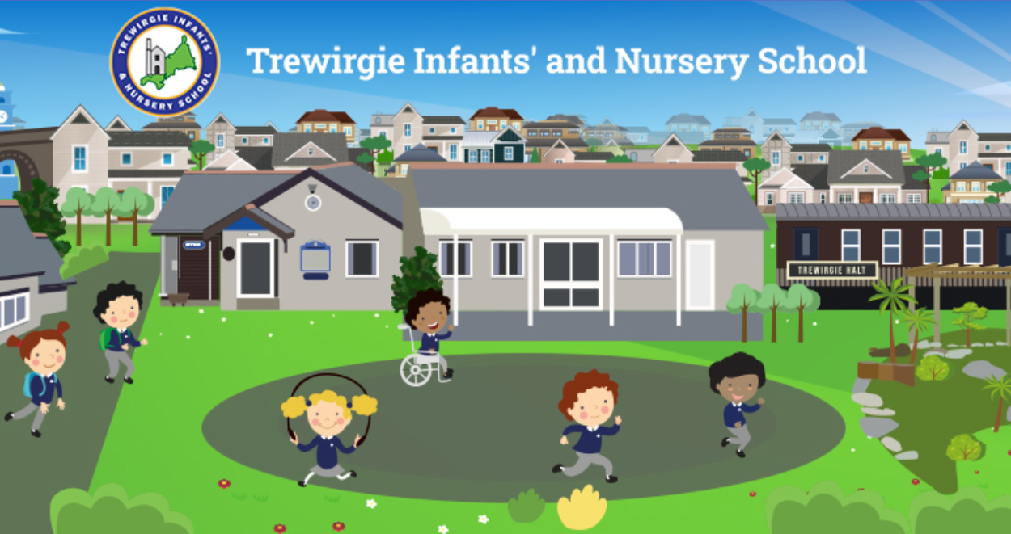

We Care, We Help, We Succeed
Welcome to our school

We look forward to you becoming part of our school family.

Starting school is a big step for your child to take, and we hope to make the transition as smooth and as problem free as possible.

We view you as partners in your child’s learning, and look forward to working with you throughout your child’s time at school.

If you have any problems or queries, please feel free to make an appointment to come and talk to us and we will do our very best to help.

Yours faithfully

Cath Callow
Head Teacher



Registration Groups

We will let you know which registration group, Class 1, 2 or 3, your child will be in in September. If possible, we would like to meet all children first before arranging class groups to ensure that we have three well balanced classes. We hope to be able to finalise classes before the end of the Summer term.

Stay and Play Sessions

Our Stay and Play sessions this year will run on the following dates…

Wednesday 2nd July – 10:15am – 11:15am
Friday 4th July –1:30pm – 2:30pm
Monday 7th July – 10:15am – 11:15am
Friday 11th July 1:30pm – 2:30pm
Monday 14th July – 10:15am – 11:15am

These are an opportunity for the children to make new friends and play in the Reception class areas, becoming familiar with the rooms and spaces ahead of starting in September. Parents/carers will also be able to have an informal talk with members of our staff. So that full attention can be given to your child who is about to start school it would be appreciated, if at all possible, that you do not bring any younger children with you.

Please use the session to play, introducing your child to other children and encouraging them to complete and tidy away one activity before moving on to another. This helps with good classroom practice.

Parents and children are welcome to attend as many sessions as they would like.
Class Structure
When the children first start with us they will be class based for registration in the morning and have the opportunity to free flow between all Reception areas for the majority of the day. Children will be supported by all staff as they learn through play. By the end of the first term they will be grouped across the cohort for Read, Write, Inc, our phonics programme stage. The children work together for maths and during small group tasks throughout the day.

RECEPTION CLASS First Day

The first day at school is a very important day for you and your child and we would like to make it a special day with happy memories. Some children come to school full of excitement, but for others it can be an apprehensive time and we would like to make the settling in period as smooth as possible for all concerned!
The timetable for the phased start is as follows:

Date | Start time | Which children | Finish time
Tuesday 2nd Sept | From 8:45 | surname A- L only | 12pm  No lunch
All Parents and Carers are invited to meet in the sports hall from 11:15 am to ask any queries and questions and find out more about the Reception school day.
Wednesday 3rd Sept | From 8:45 | surname M - Z | 12pm  No lunch
All Parents and Carers are invited to meet in the sports hall from 11:15 am to ask any queries and questions and find out more about the Reception school day.
Thursday 4th Sept | From 8:45 | All children | 12pm  No lunch
Friday 5th Sept | From 8:45 | All children | 1pm  Stay for lunch
Monday 8th Sept | From 8:45 | All children | 3:20pm  all day with lunch

All children will be in FULL TIME – from 8:45am until 3:20pm from Monday 8th September. The phased start is to help the children to settle and allow the staff time to get to know all the children in their class. Some children may need more of a phased start. Staff are happy to discuss this during meetings with parents.

Parking

To reduce the congestion around the school at the beginning and end of the school day we strongly urge parents/carers to walk to school where possible. Parking permits are available from the office for New Cut and West End car parks if you are keen to park and walk. Please take care not to park on yellow lines or blocking local drive ways.

Start of the school day

Each classroom has an outside door and these will be open from 8.45am. Teachers will be on hand to meet and greet the children at the outside area gate. We encouraged parents and carers to say goodbye to the children at this point but if your child is struggling to settle you are welcome to come into class from this time until registration starts. Staff will be on hand to welcome you in. In the case of bad weather the doors may be opened earlier, depending on staffing. Registration takes place at 8:55am.

Your child will need to find their coat peg and hang up their belongings. Lunch boxes should be placed in the set place within the classroom. Children will come and settle on the carpet of the classroom they have been allocated to. They will be greeted by the teacher and class teaching assistant.

End of the school day

The Reception classes finish at 3.20pm. The children will leave the classroom via their classroom outside doors. Parents and family members who are collecting the children can wait at the Reception gate (where the children are dropped off). The contacts recorded on the admission form are able to collect your child from the teacher at the end of the day. If anyone other than these contacts is collecting your child please let the teacher and the school office know. Staff will dismiss the children once they can see the adult who is collecting. Children are asked to wait with their classmates until they are called forward. This ensures the safety of the children.

Snack

As part of our Healthy Schools initiative and Personal, Social and Emotional curriculum, a piece of fruit is offered to each child at morning break time. The fruit is from The National School Fruit Scheme.

We have found this works particularly well with our children. It is a time when they can sit and develop their social skills, whilst helping with the preparation and cleaning up of the snack.
Water Bottles

Your child should bring a bottle of water to school every day. These need to be clearly named. We have storage in the classrooms where the children can keep their water bottle. The children then have free access to their water bottle throughout the day which helps to promote a positive attitude to healthy drinking habits.
Milk

Milk is free for all Reception children. They will be offered a cup of semi skimmed milk alongside their snack in the morning and during their lunchtime. This is optional but available to all.

Lunch

All infant children are entitled to a free cooked meal. There is a meat and vegetarian option available each day. There is also a free packed lunch option available. Children are provided with a drink of water with their school meal. All meals are prepared on site. A menu will be issued in September. We ask parents/carers to familiarise your child with the choices on offer. We ask you to select the lunch option for your child in advance on the Schoolcomms/Parent Pay app which is available from September.
Children can choose to bring a packed lunch. We encourage parents to provide the children with a balanced, healthy packed lunch. No sweets please. Children can take their water bottles into the lunch hall to have with their packed lunch. Alternatively, the children are allowed to have an additional drink in their lunch boxes. This does not have to be water but we do ask that it is a healthy option.

Communication

Communication between school and home is very important.

We communicate in the following ways:

- Weekly newsletter sent on a Friday via email.
- Emails
- Messages on the Schoolcomms app
- Text messages – if a child is absent and no reason has been provided/if a message is urgent.
- Class Dojo – an app that Reception class staff use to show you what the children are learning in class. It is also used by staff to send messages to you. You are also able to send messages to teachers using the app.
- Our school website

Sometimes photos and videos will contain other children as well as your own. You will need to give your consent to photos of your child being used on our Class Dojo, school website and newsletter. We will not use these photos without your consent. We will require all parents to sign up to Class Dojo and sign the consent box on the Registration Form allowing us to use Class Dojo when observing your children and sharing learning.

Parents Evenings
Parents/carers are invited to attend parent consultations with their child’s class teacher, these take place twice a year. This is a face to face meeting in which a discussion about your child progress can be made. Parents/carers can request a meeting to discuss their child’s progress at different times of the year. If you would like to make an appointment to see your child’s teacher, please send us a message via the Class Dojo app or ask the office staff to arrange an appointment.

Preparing your child for school

Parents and carers often ask us what they can do to help prepare their children for school. Here are our top tips.

Prepare your child to do the following independently:
- Take off/put on shoes, socks, coat and jumper. Please no shoe laces unless your child can tie them themselves. We recommend velcro fastened shoes. Anything else is a bonus but a ‘have a go’ attitude is a must.
- Use the toilet properly. All children need to be able to wipe their bottoms as best they can and wash their hands.
- Use a knife and fork to eat with.
- Read their first name (writing their name independently is great but not essential).
- Tidy away before moving on to the next activity.
- Listen carefully to others and follow simple instructions.
- Sit still and quietly and engage in an activity for at least 5 minutes (i.e. listening to a story, enjoying a puzzle etc).
- Have an understanding of sharing and taking turns.

You can also help us by…
- Supporting the school’s expectations
- Adding your own proud moments onto Class Dojo.
- Reading at home. Sharing books and stories is equally as important as your child reading to you.
- Leaving toys at home.
- Labelling EVERYTHING!

Top tips for labelling of items

- Please label everything: ALL clothes, water bottles, coats, shoes, lunch boxes etc. We really cannot stress this enough. Lost non labelled clothing is unlikely to be returned.
- It is also very important that you ensure your child recognises their labels and items that belong to them.

Checklist for starting school

- School uniform: as described on the next page.

- PE Kit: as described on the next page.

New uniform can be purchased from Trophy Textiles which is situated near Tesco Extra in Pool, you can contact them on 01209 713341. Second hand uniform is available from the school office.

- A waterproof coat. We encourage the children to be as independent as possible so please ensure you choose a coat that is user friendly for your child.

- A sun hat is required during the summer months. We also ask that sunscreen is applied at home before school. The expectation is that children who bring sunscreen to school must be able to apply it independently.

- Book Bags. Please personalise the label with a small sticker or picture. This enables the children to find their own bag independently and quickly throughout the day and at home time. These are available to buy from the office.

School Uniform

Children are required to wear a uniform. Parents are requested to ensure that their child’s hair is tidy and out of his/her face.

RECEPTION CLASS Uniform

ALL YEAR ROUND
Charcoal or grey trousers
Royal blue skirt or royal blue pinafore dress
White long/short sleeved shirt/polo shirt
Royal blue and gold striped tie
Royal blue V neck sweater/cardigan
Black/grey shoes
SUMMER TERM (optional)
Blue and white checked dress
White short sleeved shirt
Charcoal or Grey shorts
Sunhats for playtimes are advisable
PE KIT
Royal blue shorts
Yellow t-shirt
Black plimsolls
Soft tracksuit trousers may be worn for outdoor PE lessons

Performances and Celebrations

Throughout the year we have several occasions where children are filmed and photographed e.g. for the Christmas play. If you do not wish your child to be filmed or photographed for these purposes, please indicate this on the admission form.

Before and After School provision

Breakfast club is open from 7:45am every morning. Children are offered a variety of healthy breakfast options including cereals, fruit and brown toast.
The children are taken to their classrooms at the start of the school day.

After school care is available every day from the end of the school day (3:15pm) until 5:15pm. A snack and drink is available. Children have the opportunity to meet their friends, take part in arts and crafts activities, painting, sewing and junk modelling challenges plus opportunities to watch a film and relax. They have a range of books and toys for all age groups.

Please contact the school office if you would like more information. Both sessions need to be booked and paid for in advance via the school office.

How to contact us…

If you have any questions or queries regarding any aspect of this booklet or your child’s transition to school please contact us by the following methods:

Telephone 01209 216111
Email trewirgieinf@tpacademytrust.org

