Wednesday 5th January 2022
L.O. To identify and locate the 7 Continents and 5 Oceans on a World map.

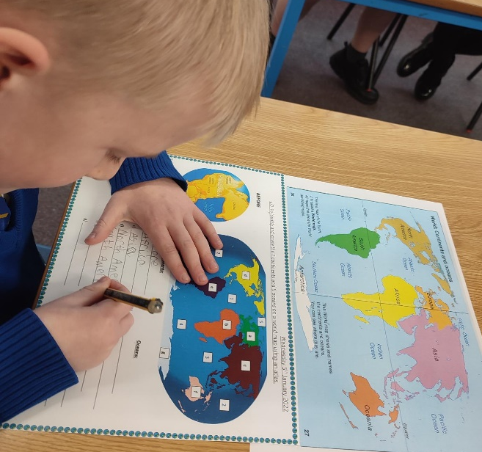
Today we started our cool new Geography topic, we started by taking a class retrieval quiz to see what we already knew and what knowledge we needed to build upon. We used songs and real atlases to learn about the world, continents, and oceans.

I liked finding the
continents and oceans on the map
but I loved making my own map on
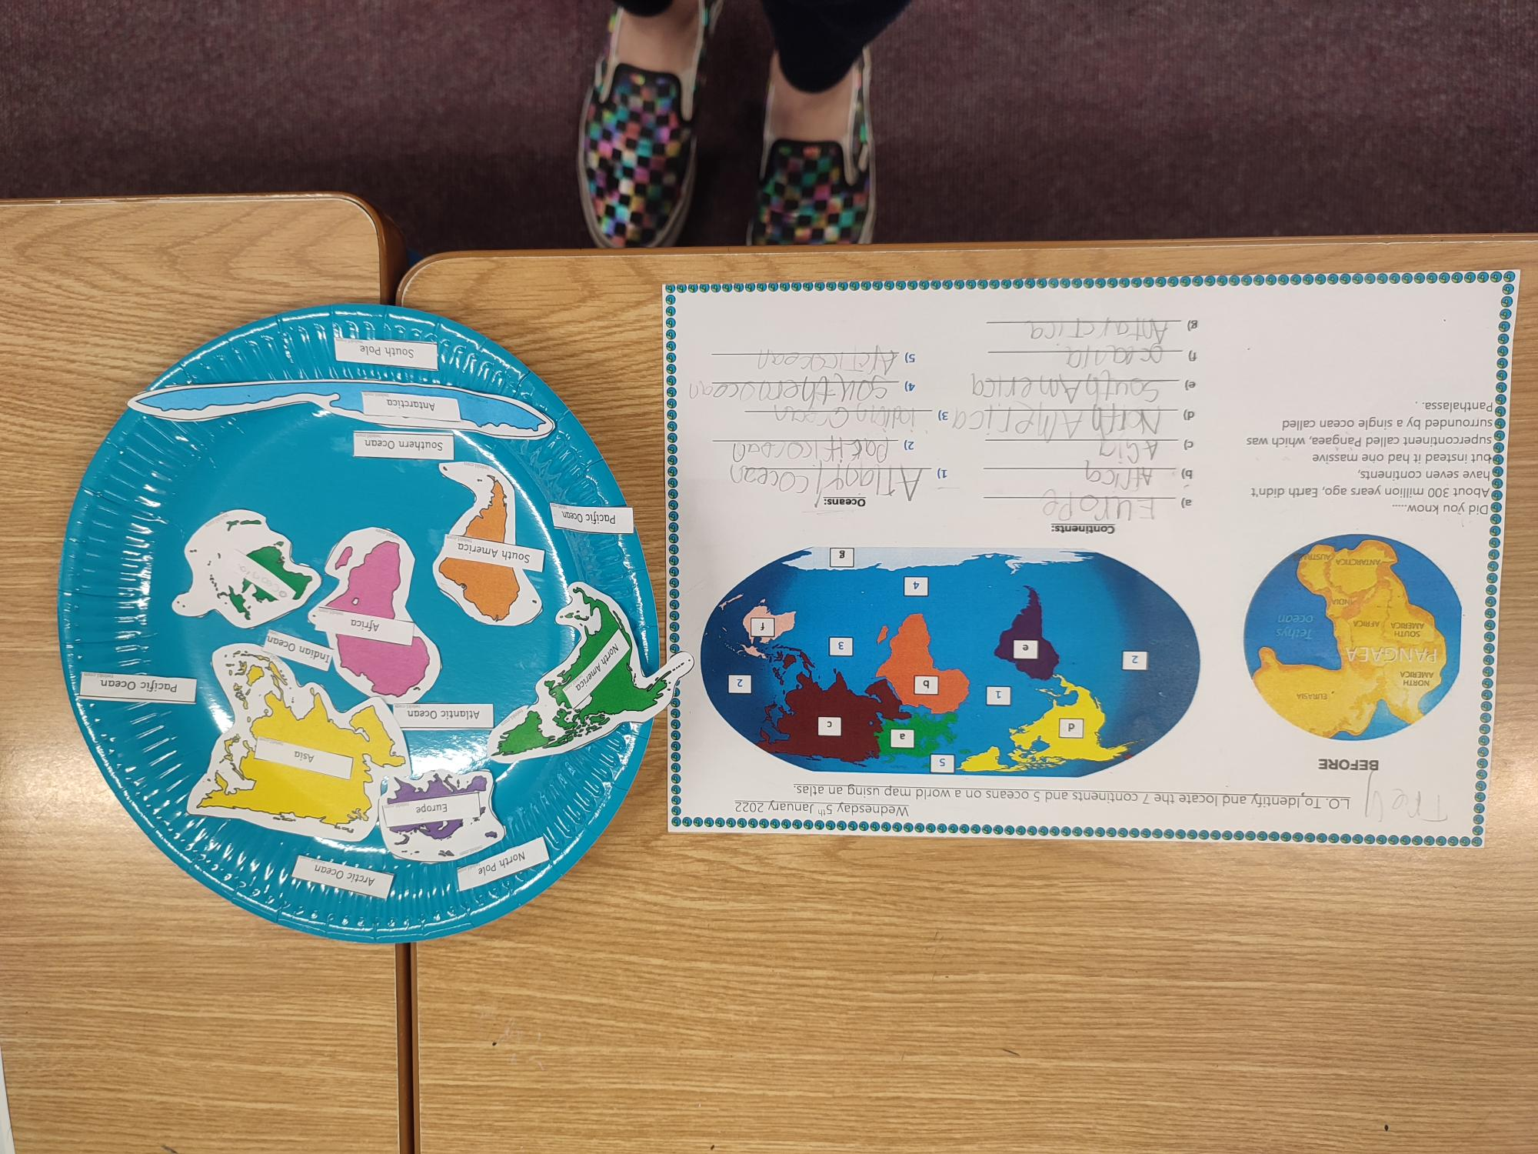
the paper plate! Trey
At the end of the lesson, we did the quiz again and we knew lots more information, my brain grew lots! Cordelia

