**Keeping Children Safe in Education**

**Child Protection and Safeguarding Policy**

**Review Summary**

|  |  |
| --- | --- |
| **Approval Date:** | **May 2025** |
| **Next Review Date:** | **May 2029** |

**Accessibility Plan for Trewirgie Infants’ & Nursery School 2020-24 ‘We care, we help, we succeed’ Mission statement of Trewirgie Infants:**

**OUR MISSION:** • To inspire children to engage in learning, and be valued members of a caring, supportive, and successful school.

• For all our children to develop life- long learning skills; to be independent and creative thinkers and to be socially confident.

• To enable children to be successful through a curriculum that captures their interests, stimulates their ideas, encourages inquisitiveness and critical thinking and meets their needs. At Trewirgie Infants’ and Nursery school we are ambitious for all our pupils. Our goal is to: • Inspire and educate our children in a happy, safe and enjoyable environment

• For all our children to make good academic progress, to develop life skills, to be independent and creative thinkers and to be socially confident

• To enable children to engage with their own learning through a curriculum that captures their interests, encourages creativity and inquisitiveness and makes learning fun.

**Vision Statement for pupils with SEND:** The vision at Trewirgie Infants’ and Nursery School is for all children with Special Educational Needs and Disabilities (SEND) to have access to inclusive learning within school thereby providing opportunities for realizing aspirations, achieving potential and participating fully in education and the wider society Introduction At Trewirgie Infants’ & Nursery School we are committed to providing a fully accessible environment which values and includes all pupils, staff, parents and visitors regardless of their education, physical, sensory, social, spiritual, emotional and cultural needs. We are committed to challenging negative attitudes about disability and accessibility and to developing a culture of awareness, tolerance and inclusion.

**Rationale**

Trewirgie Infants’ & Nursery School plans, over time, to increase the accessibility of provision for all pupils, staff and visitors to the school. *We believe that this Accessibility Plan is compliant with current legislation and requirements as specified in Schedule 10, relating to Disability, of the Equality Act 2010. School Governors are accountable for ensuring the implementation, review and reporting on progress of the Accessibility Plan over a prescribed period.*

**Procedure**

1. The Trewirgie Infants’ & Nursery School Accessibility Plan has been drawn in conjunction with staff and governors of the school and will advise other school planning documents. The Accessibility Plan will be reported upon annually in respect of progress and outcomes, and provide a projected plan for the four year period ahead of the next review date.
2. The Accessibility Plan is structured to complement and support the school’s Equality Objectives and will similarly be published on the school website. We understand that the LA will monitor the school’s activity under the Equality Act 2010 (and in particular Schedule 10 regarding Accessibility) and will advise upon the compliance with that duty.
3. We are committed to providing an environment that enables full curriculum access that values and includes all pupils, staff, parents and visitors regardless of their education, physical, sensory, social, spiritual, emotional and cultural needs. We are committed to taking positive action in the spirit of the Equality Act 2010 with regard to disability and to developing a culture of inclusion, support and awareness within the school.
4. The Trewirgie Infants’ & Nursery School Accessibility Plan shows how access is to be improved for disabled pupils, staff and visitors to the school in a given timeframe and anticipating the need to make reasonable adjustments to accommodate their needs where practicable. The Accessibility Plan will contain relevant and timely actions to:

• increase access to the curriculum for pupils with a disability, expanding the curriculum as necessary to ensure that pupils with a disability are as, equally, prepared for life as are the able-bodied pupils; (If a school fails to do this they are in breach of duties under the Equalities Act 2010); this covers teaching and learning and the wider curriculum of the school such as participation in after- school clubs, leisure and cultural activities or school visits - it also covers the provision of specialist or auxiliary aids and equipment, which may assist these pupils in accessing the curriculum within a reasonable timeframe;

• improve access to the physical environment of the school, adding specialist facilities as necessary --‐ this covers improvements to the physical environment of the school and physical aids to access education within a reasonable timeframe;

• improve the delivery of written information to pupils, staff, parents and visitors with disabilities; examples might include handouts, timetables, textbooks and information about the school and school events; the information should be made available in various preferred formats within a reasonable timeframe.

5. The Accessibility Plan relates to the key aspects of physical environment, curriculum and written information

6. Whole school training will recognise the need to continue raising awareness for staff and governors on equality issues with reference to the Equality Act 2010.

7.The Accessibility Plan should be read in conjunction with the following school policies, strategies and documents:

• Curriculum Policy

• Equality Objectives

• Continuing Professional Development Policy

• Health & Safety Policy (including off-site safety)

• Special Educational Needs Policy/SEN Information report

• Behaviour Management Policy

• School Development Plan

• Asset Management Plan/Suitability Survey

8.The Accessibility Plan will be published on the school website

9. The Accessibility Plan will be monitored through the Local Monitoring Committee.

10.The Accessibility Plan may be monitored by Ofsted during Inspection processes in relation to Schedule 10 of the Equality Act 2010

**Aims and Objectives**

**Ensuring Access for all pupils to the curriculum**:

Improving teaching and learning lies at the heart of the school’s work.

Through self‐review and Continuous Professional Development (CPD), we aim to enhance staff knowledge, skills and understanding to promote excellent teaching and learning for all children. We aim to meet every child’s needs within mixed ability, inclusive classes. It is a core value of the school that all children are enable to participate fully in the broader life of the school. Consequently, all children have always been permitted to attend age relevant after school clubs, leisure and cultural activities and educational visits.

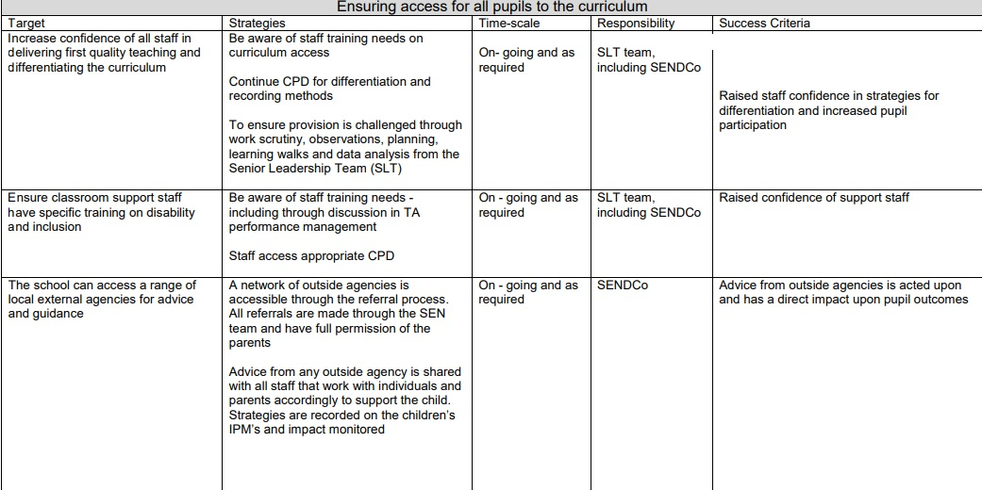

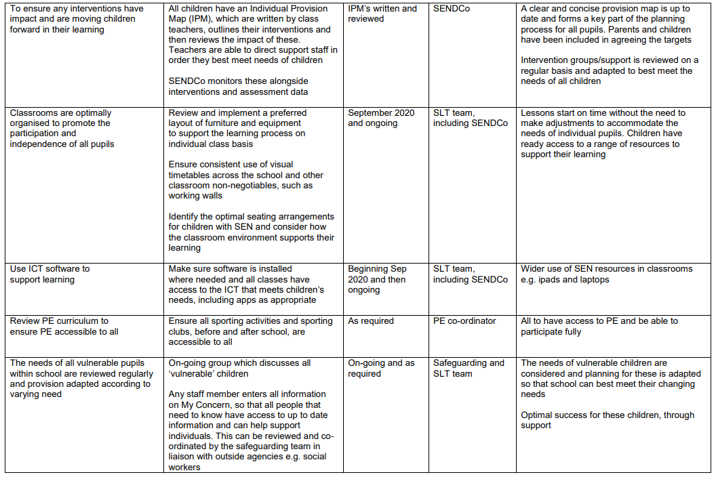

**Improving access to the physical environment of the school**

The school is built on a slope, but has been adapted to ensure all areas can be accessed effectively.

The site has a school reception/office building, a Nursery & attached school PE hall, EYFS and dinner hall and KS1 building. A new build took place in summer 2016 which include ramped access to the new sports hall. The school also has:

• Wheelchair access to all year groups, which have separate entrances

• A disabled parking bay

* Walkways have replaced steps, where possible
* Steps are lined with yellow markings to aid the visually impaired

• Reception is clearly visible & signposted upon entrance to the site and is wheelchair accessible

• Internal signage is in place and a school plan is available to visitors upon request.

We have a wide range of equipment and resources available for day-to-day use. We keep resource provision under constant review. Equipment is logged within an Asset Management system.

The site is regularly reviewed by the Health and Safety team from TPAT, who visit routinely throughout the year. Daily and weekly checks are carried out by the caretaker. Safety check lists for classrooms are carried out termly.

**Ensuring access to the physical environment of the school**

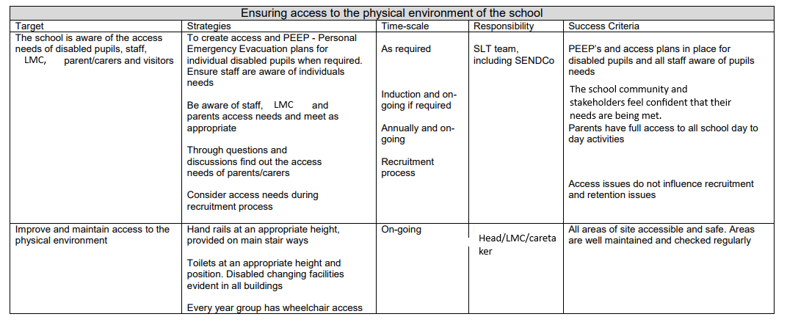

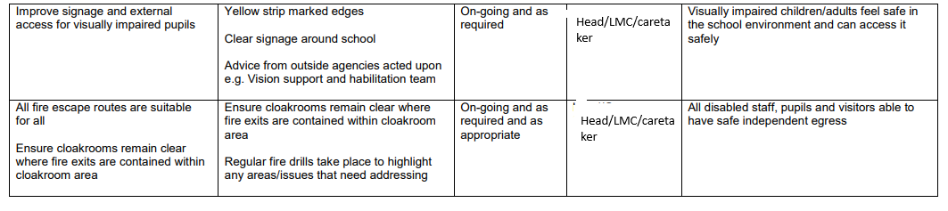

**Improving and Monitoring the delivery of written information to all pupils and parents/carers**

This will include planning to make written information that is normally provided by the school accessible to all pupil and adults. The information should take account of pupils’ disabilities and home language as well as pupils’ and parents’ preferred formats and be made available within a reasonable timeframe. In planning to make written information available to all pupils and families, we need to continually review current levels of need and be able to respond to changes in the range of need. The school will need to identify agencies and sources of such materials to be able to make the provision when required. The school’s IT infrastructure and office staffing will enable us to access a range of materials supportive to need.

|  |  |  |  |  |
| --- | --- | --- | --- | --- |
| **Improving & Monitoring the delivery of written information to all pupils** | | | | |
| Target | Strategy | Time Scale | Responsibility | Success Criteria |
| Availability of communication in different formats | The school will identify sources for converting written formats. For example, ensuring all communication can be translated. | On-going | SLT | The school will provide written format in different forms for individuals |
| Parents are happy with the school’s communication methods. | Provide different methods of communication for example, email, Dojo, text and the newsletter.  Annual parent survey | On-going | SLT | School has a good understanding of how parents want to receive communication. |
| Ensure that information is communicated effectively for those who are visually impaired | Provide larger text and clear print. | As required | SLT | Excellent communication for all. |
| Provide all information in other languages. | Access to translators | As required | SLT | All pupils and parents feel included. |
| Provide information in an appropriate way for those who have language difficulties. | Sign language and Makaton to be used when necessary. Training for Makaton is ongoing. | As Required | SLT | All pupils and parents feel included. |