Trewirgie Infant and Nursery School Special Educational Needs and Disability (SEND) School Offer updated 2026
Autumn Term 2026: The SEND School Offer will be updated annually or at a time where individual needs are necessitated.
This SEND School Offer has been written by the SENDCo and SLT in consultation with the Headteacher and staff. It has been shared with the governing body, parents, carers and children and is published on the website. This report is to be read in conjunction with our Equality Policy and Plan (which is inclusive of SEND) and the SEND Information Report.

Trewirgie Infant and Nursery School SEND Information Report complies with the statutory requirements laid out in the SEND Code of Practice 0-25
(Jan 2015) and has been written with reference to the following guidance and documents:
· Equality Act 2010: Advice for schools DfE Feb 2013
· SEND Code of Practice 0-25 (Jan 2015)
· Schools SEN Information Report Regulations 2014

Responsible Persons
The responsible persons for SEND is Mrs Lisa-Marie Clarke (SENDCo – NPQ SEND 2025/26)
The Local Monitoring Committee member responsible for SEND is currently Mrs Emma Guppy-Wilcox

Aims and Objectives
● The staff and governing body will do their best to ensure that the necessary provision is made for any child who has special educational needs
and ensure that, where the Headteacher or the appropriate governor has been informed by the LEA that a child has special educational needs.
These needs will be made known to all who are likely to work with them.
● Our school ensures an equal opportunities approach, as set out in our Equality Policy and Plan, which is an inclusive, whole school approach to
the teaching, learning and education of all children.
● Trewirgie Infant and Nursery School is aware of the importance of identifying and providing for those pupils who have special educational needs or a
disability, and those who are high ability or have significant medical needs.
● The SENDCo will draw up and report annually on the effectiveness of the school’s work for children with special educational needs, report this to
the Headteacher and Governors, and will then share this on the school website.
● The staff will ensure that children with special educational needs join in the activities of the school together with children who do not have
special educational needs, so far as that is practical and compatible with the child receiving the necessary provision, the efficient education of
other children in the school and the best use of resources.
● The school applies an Accessibility Plan to ensure our school is inclusive. (It is updated every three years or as individual needs necessitate).
● The staff will aim to include pupil and parent voice in all aspects and stages of SEND provision within the school.

The Graduated Approach
The graduated approach describes the process by which Trewirgie Infant and Nursery School identifies and manages children with SEND. There are three levels of support and provision offered by our school:
Wave 1. Whole School Approaches – All children in the school receive this universal provision;
Wave 2. Additional, targeted support and provision – Some children who are not making expected progress may access some of this additional support; and
Wave 3. Specialist, individualised support and provision – specific individuals with more significant needs may access additional provision through this specialist provision.
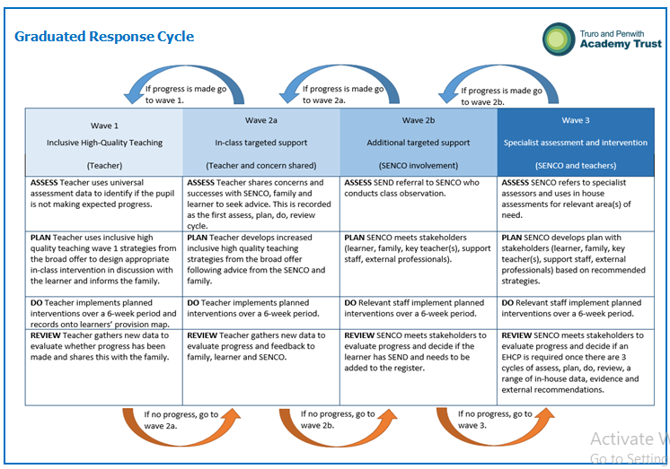
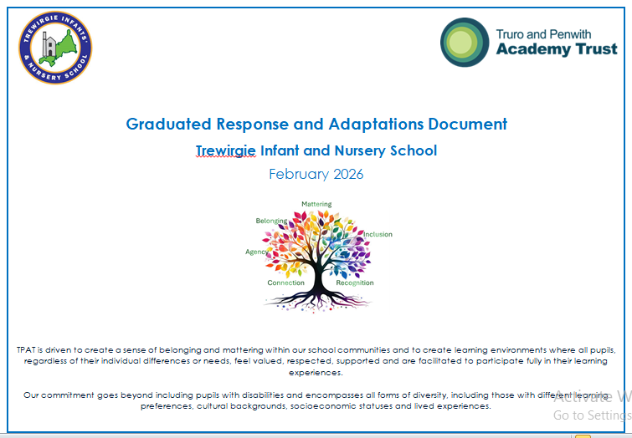

There are 4 areas of need as defined in the Code of Practice (Jan 2015):
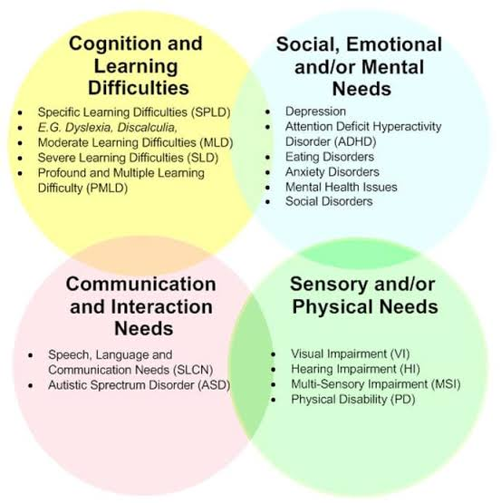
· Cognition and Learning
· Communication and Interaction
· Sensory and/or Physical Needs
· Social, Emotional and Mental Health Difficulties

The levels of support and provision offered at Trewirgie Infant and Nursery School .This section of the SEND Information Report details the three levels of provision that are available in our school to provide effective learning.
Decisions as to which support children receive will come from consultation with the teacher, SENDCo, SLT and Head Teacher, and will be shared with the children and parents/carers as part of the graduated approach.
- Listening to and responding to children and young people
Whole school approaches The universal offer to all children, additional, targeted support and provision , Specialist, individualised support and provision

● Detailed planning and objectives for the whole curriculum.
● Termly opportunities for parents/carers to meet teachers for all children
● Pupil conferencing
●Pupil questionnaires
● Children who have SEND are included in all consultation groups
● Additional provision is developed in light of pupil voice
● Individual support is responsive to the views of the child
● Child’s views (where possible and appropriate) form an integral part of TAC meetings and SEN Assess, Plan, Do, Review meetings.
● Child’s views are incorporated into personalised curriculums (Learning Plans)
● Documentation is presented in a format that is accessible to the child where possible, and child views are collected through a range of media.

- Partnership with parents and carers
Whole school approaches The universal offer to all children, Additional, targeted support and provision Specialist, individualised support and provision

● The school works in partnership with all parents/carers.
● We have an ‘open door’ policy whereby parents/carers may talk to staff members at the beginning and the end of the day.
● Parents/carers attend FACE2FACE meetings in the Autumn and Spring terms, with a report in the Summer Term, and meeting opportunities to follow up on it.
● Parent/Carer Questionnaire sent home annually
● Parental/carer weekly newsletters andclass Dojo messages home.
● Parent/carer meetings for information sessions.
● Families are invited to attend information sessions about supporting their children at home.
● Virtual sites such as ‘Times table Rockstars’ and ‘Numbots’ are available to support learning at home.
● Parents/carers are able to contact school about concerns at any time.
● Support via the Early Help Hub, such as a family support worker and the School nursing service.
● Contact with families via phone or email.
● Additional meetings to discuss specific needs outside of FACE2FACE meetings.
● Parents/carers are supported in attending, and are actively involved in, all TAC meetings and SEND Assess, Plan, Do, Review meetings where their views are an integral part of the process.
● All parents/carers of children on the Record of Need are invited to termly IEP (Individual Education Plan) review meetings.
● For children working with outside agencies such as Speech and Language Therapist, Educational Psychologist etc. Parents/carers will be invited into school to meet with these professionals to understand the nature of the support taking place.
● Tapestry is used in our Early Years classes to help document and share

- The curriculum Whole school approaches
The universal offer to all children Additional, targeted support and provision Specialist, individualised support and provision

● The curriculum is designed and adaptations are made to ensure the inclusion of all children
. ● All children, regardless of ability, have full access to the curriculum.
● Lessons are planned and delivered catering to all styles of learners
. ● Termly data tracking to identify children who need specific interventions.
● We ensure a broad, balanced and relevant curriculum
. ● High expectations for involvement in learning.
● Intervention packages are needs lead.
● The progress of all children taking part in intervention groups is measured termly.
● The intervention packages are adapted in light of progress.
● Children are supported in accessing all areas of the curriculum regardless of their SEN, with adult support where necessary.
● Advice and support provided by outside agencies (Educational Psychologist, Speech and Language Therapist, Occupational Therapist etc.) is followed and incorporated into individualised curriculums for identified children
● Clear learning objectives

- Teaching and learning
Whole school approaches The universal offer to all children Additional, targeted support and provision Specialist, individualised support and provision

● Clear learning objectives shared with all children
● Teaching of strategies to enable the children to retain and retrieve information
● In-class scaffold and support of learning activities and outcomes
● Reinforcement or extension activities
● Quality feedback – positive named comments, strengths and next steps identified
● Non-written tasks: recording: taping, drawing, Teacher/TA scribing
● Paired reading
● Small group targeted interventions – number sense, handwriting,
● Individual support in class (where appropriate)
● Read Write Inc (phonics) SEND intervention
● Targeted reading/spelling/number sense interventions
● Speech and Language Therapy
● Outside agency guidance, outreach visits etc. Teacher of the deaf, Vision support services, Educational Psychology, Penhaligon’s Friends, Occupational Therapy, cognition and learning service
● Feedback from assessments – pupil conferencing
● Working/learning walls and displays
● Access to learning support materials – word lists/mats, number lines, 100 squares
● Use of concrete equipment in maths
● Private Speech and language therapist visits the school twice a term
● Home/School communication sheets
● Individual ICT equipment i.e. ipads
● Individual seating position within the classroom 5. Self-help skills and independence Whole school approaches
The universal offer to all children Additional, targeted support and provision Specialist, individualised support

- Self-help skills and independence
Whole school approaches The universal offer to all children Additional, targeted support and provision Specialist, individualised support and provision

● All children are encouraged in their independent learning skills
● Appropriate labelled resources are available in all classrooms to promote independence
● Visual timetable
s ● Learning wall in room and other prompts
● Key vocabulary and success criteria displayed
● Children have personalised equipment to help them learn such as talking tins, overlays and number squares etc.
● Where necessary, children have access to visual timetables, task cards and prompt cards.
● Additional adult support is shared to build resilience in the child so that they have self-coping strategies for when and if the TA is absent, and to build independence where appropriate.
● When appropriate personalised task boards and timetables are available to support independence
● Now and next boards
● Teaching and modelling of learning behaviours
● Whole school Trauma Informed School approaches
● Behaviour system that focuses on positive choice and visual reminders
● Individual visual timetables and other visual aids such as traffic lights, choices boards
● Quiet spaces/break-out areas

- Health, wellbeing and emotional support
Whole school approaches The universal offer to all children Additional, targeted support and provision Specialist, individualised support and provision

● PSHE/RSHE (Jigsaw) lessons include all children
● Whole school Trauma Informed Schools/Thrive approaches
● Risk assessments and safety policies are in place to ensure all children are safe within the school.
● Weekly celebration assembly
● All teachers and teaching assistants first-aid trained with EYFS team paediatric trained
● Whole school meta-cognition approaches-WALKTHRUS
● If appropriate intervention groups to help self-esteem issues are available.
● TACs, Early Support meetings and reviews are supported by a range of agencies as appropriate.
● Additional support for pupils can be requested through the Early Help Hub
● Children with specific medical conditions and allergies have an individual health care plan and risk assessment, where necessary
All staff have allergy training sand can administer an Epi-Pen if needed

7. The physical environment (accessibility, safety and positive learning environment
. Whole school approaches The universal offer to all children Additional, targeted support and provision Specialist, individualised support and provision

● All areas of the school are accessible to everybody
● Wheelchair access is available
● Children feel safe in an environment where bullying is absolutely minimal and dealt with effectively
● There is a designated ‘Designated Safeguarding Lead’ (Ms Clair Bateman), and two Deputy DSLs (Mrs Lisa-Marie Clarke and Mr Craig Jenkin)
● Access to specialist equipment resources where appropriate (overlays, sloping ramps)
● Quiet areas are available in class as well as break-out spaces in corridors
● Designated teaching areas are available
● Dedicated resources matched to pupils’ needs are available
● Liaison with appropriate health professionals/teams and a named Child in Care lead (Mrs Lisa-Marie Clarke).
● Teachers focus on rewarding good behaviour to promote a positive learning environment

- Transition from year to year and setting to setting
Whole school approaches The universal offer to all children Additional, targeted support and provision Specialist, individualised support and provision

● On site Nursery as part of our school. EYFS teachers clearly identify children who may need extra support through transition sessions.
● Reception transition is well planned and takes place regularly and progressively.
● Receptions teachers visit pre-school settings to aide transition (where possible
● There are strong links with the receiving Schools. SENDCo/Class teachers
● Previous interventions are shared and discussed at transition meetings in school (year to year).
● Additional informal transitional classroom, and the wider school environment, visits are made for small groups/individuals.
● SENDCo liaises with Primary schools and pre-schools to ensure all information is shared before transition
● Where necessary, individualised transition programmes are put in place including additional visits, photo books etc.identify children who may need additional support.
● Taster sessions happen throughout the year and in a variety of curriculum areas, including additional SEN open mornings during the summer holidays for SEN children.
● Moving-up days across the school allows all children to work with their new teacher.

● Staff meetings are planned in for transition to the next class/year group

- Services and organisations that support us:

The Speech and Language Therapy Service supports children and young people in Cornwall aged 0-19 years who have difficulties with communication, or with eating, drinking and swallowing. SLTs aim to help to develop the skills of parents/carers and school staff who support the child in their everyday environments. They then provide therapy for some children and set goal summaries for the school. Teaching assistants in the school work with children to achieve these goals.

Educational Psychology Service -Educational Psychologists are specialists in learning, emotional well-being and child development. They work directly or indirectly with children and provide advice to their parents and other adults who support them. They advise on strategies to help the child overcome their barriers to learning. If necessary, they advise us to apply for statutory assessment for an Education and Health Care Plan (EHCP).

Vision Support Team- The Vision Support Team provides specialist support for children and young people with diagnosed visual impairments in homes and schools. Children who have been diagnosed with specific visual impairment are seen in school by a teacher from the Vision Support Service. The school is also given advice regarding classroom strategies and supplied with assistive technologies.

Hearing Support Team -The Hearing Support team provides specialist support for children affected by educationally significant hearing loss. They provide advice on the educational management of hearing loss where this impacts significantly on the child or young person’s education. Qualified Teachers of the Deaf visit children at home or in their school setting to undertake educational audiology assessments, observe and work with the individual, liaise with the parents and relevant staff in order to identify that individual’s educational needs related to their hearing loss and provide advice or direct support as appropriate.

Autism Spectrum Disorder Assessment Team (ASDAT) -The Autism Spectrum Disorder Assessment Team (ASDAT) is an experienced multidisciplinary team for children and young people up to their 16th birthday who have complex social and communication difficulties. It is made up of the following disciplines: Child and Adolescent Psychiatry, Community Paediatrics, Clinical Psychology, Occupational Therapy and Speech and Language Therapy.
CAMHS (Children and Adolescent Mental Health Services) Specialist community child and adolescent mental health services (CAMHS) provide assessment, advice and treatment for children and young people with severe and complex mental health problems. CAMHS also provide support and advice to their families or care.

School Nurse- School nurses are qualified and registered nurses who support children and young people in making healthy lifestyle choices, enabling them to reach their full potential and enjoy life. School nurses work across education and health, providing a link between school, home and the community. Their aim is to improve the health and well-being of children and young people.

Cognition and Learning Team -This service supports schools in ensuring the effective inclusion, achievement and progression of children and young people with cognition and learning needs.

Early Help Hub- Most of the services above are accessed via the Early Help Hub who triage the information we provide and then ensure we are put in contact with the correct professional service.

Answers to Frequently asked Questions

1. How does your school know if children need extra help and what should I do if I think my child may have special educational needs?
We use a variety of assessment strategies that are monitored half-termly to ensure the progress of all children. If your child is not making
progress then further investigative measures will take place. The school has an open-door policy so any educational issues can be shared at any
time with staff.

2. Who is responsible for the progress and success of my child in school?
The overall responsibility for your child’s success lies with the Headteacher and governing body, this is shared by teaching staff, teaching
assistants, yourselves and your child.

3. How will the curriculum be matched to my child’s needs?
Trewirgie Infant and Nursery School has an inclusive ethos and aims to provide a broad and balanced curriculum, which meets the interests and imagination
of all children. Children who are identified as needing additional Special Support will have an individual plan that outlines how the curriculum
is made accessible to them. All children in the school access learning to match their needs as individual learners.

4. How will Trewirgie Infant and Nursery School staff support my child?
School staff aim to support all children to reach their potential through inclusive teaching, individual targets, targeted
interventions and pastoral care. School staff, including the teachers, Headteacher and the SENDCO are available to parents for the discussion of
individual needs where needed.

5. How will I know how my child is doing and how will you help me to support my child’s learning?
The school works in partnership with all parents/carers. Parents/carers and children are consulted and involved in the process of the graduated
approach to SEND. Parents/carers attend progress review meetings twice a year and a formal report is sent home at the end of the year.
Following this, there is the opportunity to discuss any information from the report.

6. How do I know that my child is safe in school?
Risk assessments and safety policies are in place to ensure all children are safe within the school. Designated local comitte members have responsibility for
health and safety, and safeguarding. The school premises are secure.

7. What SEND training have the staff at school had or are having?
The staff have had a range of training that is on-going or delivered through insdet or training specific training. All staff have had Safeguarding Tier 2
training. There are many individual areas of expertise amongst teachers and TAs and training is ongoing.

8. How will my child be included in activities outside the classroom including school trips?
Provision is made for all children to take part in all learning activities. The provision needed to make all areas accessible will depend on the needs of the child to ensure all activities are inclusive.

9. How are the school’s resources allocated and matched to children’s special educational needs?
Appropriate resources are available in all classrooms to help all children. Interventions are tracked and monitored every term alongside pupil
progress data meetings. For children with an Education, Health, Care Plan (EHCP), the school will cover up to the first £6000 of provision. If
additional support above this is deemed necessary by the Local Authority and the school in order for the EHCP to be successfully applied, this
will be provided to the school from the Local Authority

10. How is the decision made about what type and how much support my child will receive?
For children receiving SEND Support, and who are subject to an IEP (Individual Education Plan) staff and parents will create a child- focused
plan, detailing the provision and targets needed to make progress when appropriate. If your child is subject to an EHCP, the Local Authority
Assessment and Provision Team, in conjunction with the school, will detail the provision school needs to provide and whether additional funds
are needed to implement this.

11. Whom can I contact for further information?
Mrs Clarke SENDCO
lclarke@trewirgieinf.tpacademytrust.org

12. What should I do if I feel that the Local Offer is not being delivered or is not meeting my child’s needs?
Contact us at school, but if you feel your need is still not being met please refer to our complaints policy.

13. How is your SEND Information Report reviewed?
Our SEND Information Report is reviewed by the SENDCo and the Senior leadership team. Involvement and consultation of staff is used to
update relevant sections at staff INSET and meetings. The data and impact of SEND support is collated at Pupil Progress Meetings termly and
added to the report annually in the summer term. This report is reviewed annually or at a time where individual needs are necessitated.

