Year 2 Knowledge organiser Continents and Oceans
What will we be learning?
- Understanding where I am in the world.
- Locating the seven continents.
- Locating the five oceans.
- Human features of the continents.
- Physical features of the continents.
Key facts
The seven continents:
Antarctica, Africa, Asia, Europe, North America, Oceania and South America.
The five oceans:
Atlantic, Arctic, Indian, Pacific and Southern.
Key knowledge
The world is made up of many countries. The countries can be grouped into continents.
The large amounts of water between each continent are called oceans.
Some of the continents are joined by land. Others are separated by oceans.
Human features are made by people.
Physical features are created by nature.
The Equator is an invisible line that separates the Northern and Southern hemispheres, like a belt.
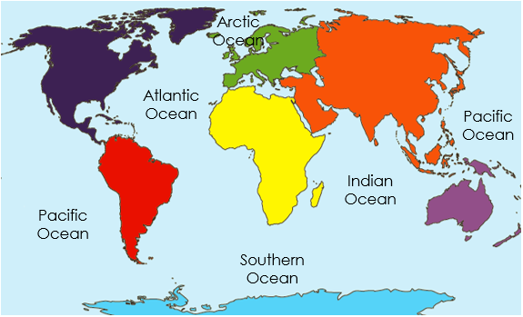
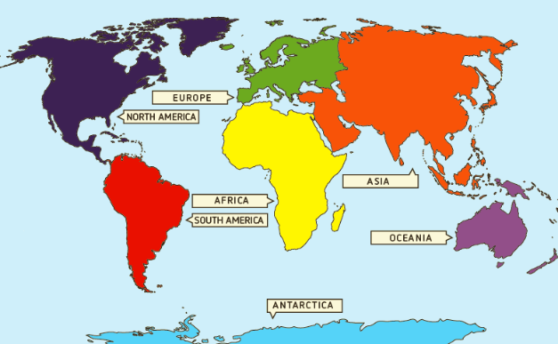

Place names | Geographical terms and processes | Locational terms
Europe  United Kingdom  Cornwall  Redruth | Atlas  Continent  Globe  Human features-Made by people  Ocean  Physical features-Naturally occurring | East  Hemisphere  North  South  South Pole  Noth Pole  West  Equator line  Compass
Glossary
continent: a very large area of land
hemisphere: half of the globe
ocean: a huge area of salty water

