Our Curriculum Vision Statement 2026/2027

At our Infant School, we believe that every child deserves the very best start to their educational journey. Our curriculum is built upon a strong foundation of communication, language, reading, writing, mathematics and personal development, ensuring that every child develops the knowledge, skills and confidence they need to succeed both now and in the future.
From Nursery to Year 2, our curriculum is designed around the principle that strong foundations lead to lifelong success. We recognise that children arrive with different experiences, strengths and needs, and we are committed to ensuring that every child is supported to flourish from their individual starting point. Through high expectations, nurturing relationships and carefully planned learning experiences, we enable all children to achieve their full potential.
Our Foundational Skills approach sits at the heart of everything we do. We prioritise the development of communication and language, oracy, reading, writing, mathematical understanding, physical development and self-regulation because we know these are the essential building blocks for future learning. These skills are explicitly taught, revisited and strengthened throughout a child's journey, enabling them to access an ambitious and knowledge-rich curriculum.
We believe that every child should become a confident communicator, enthusiastic reader and successful learner. Rich stories, purposeful talk, ambitious vocabulary and meaningful learning experiences are woven throughout our curriculum to develop children's curiosity, imagination and understanding of the world around them. Through opportunities to question, discuss reason and reflect, children learn to think deeply and express themselves with confidence.
Our curriculum is fully inclusive and designed to remove barriers to learning. We know our children well and adapt our teaching so that all learners, including those with SEND, disadvantaged pupils and those facing additional challenges, can access the same ambitious curriculum and experience success. We work closely with families and external agencies to ensure that every child feels valued, supported and able to thrive.
Learning is carefully sequenced from Nursery to Year 2 so that knowledge and skills build progressively over time. Through retrieval, repetition and purposeful practice, children develop secure understanding and retain what they have learned. We encourage children to make connections across subjects, apply their learning in meaningful contexts and develop independence, resilience and a love of learning.
By the end of Year 2, we aspire for every child to leave us as a confident, capable and compassionate learner, equipped with the foundational knowledge, skills and character needed to embrace the opportunities and challenges of Key Stage 2 and beyond.
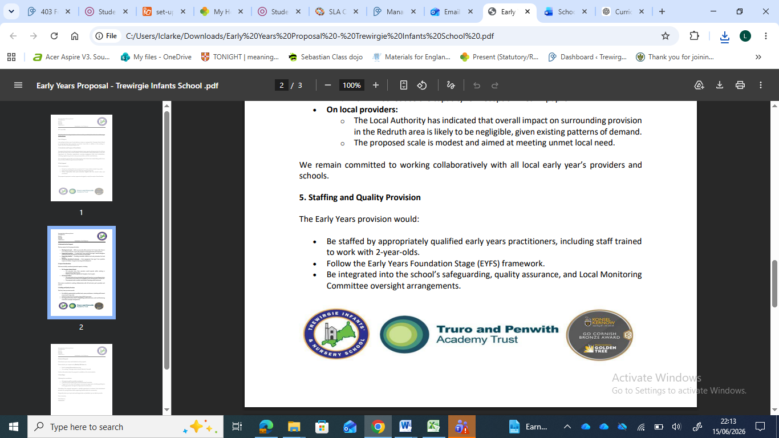
At our school, we are building “Strong Foundations so every child has a Limitless Future."

