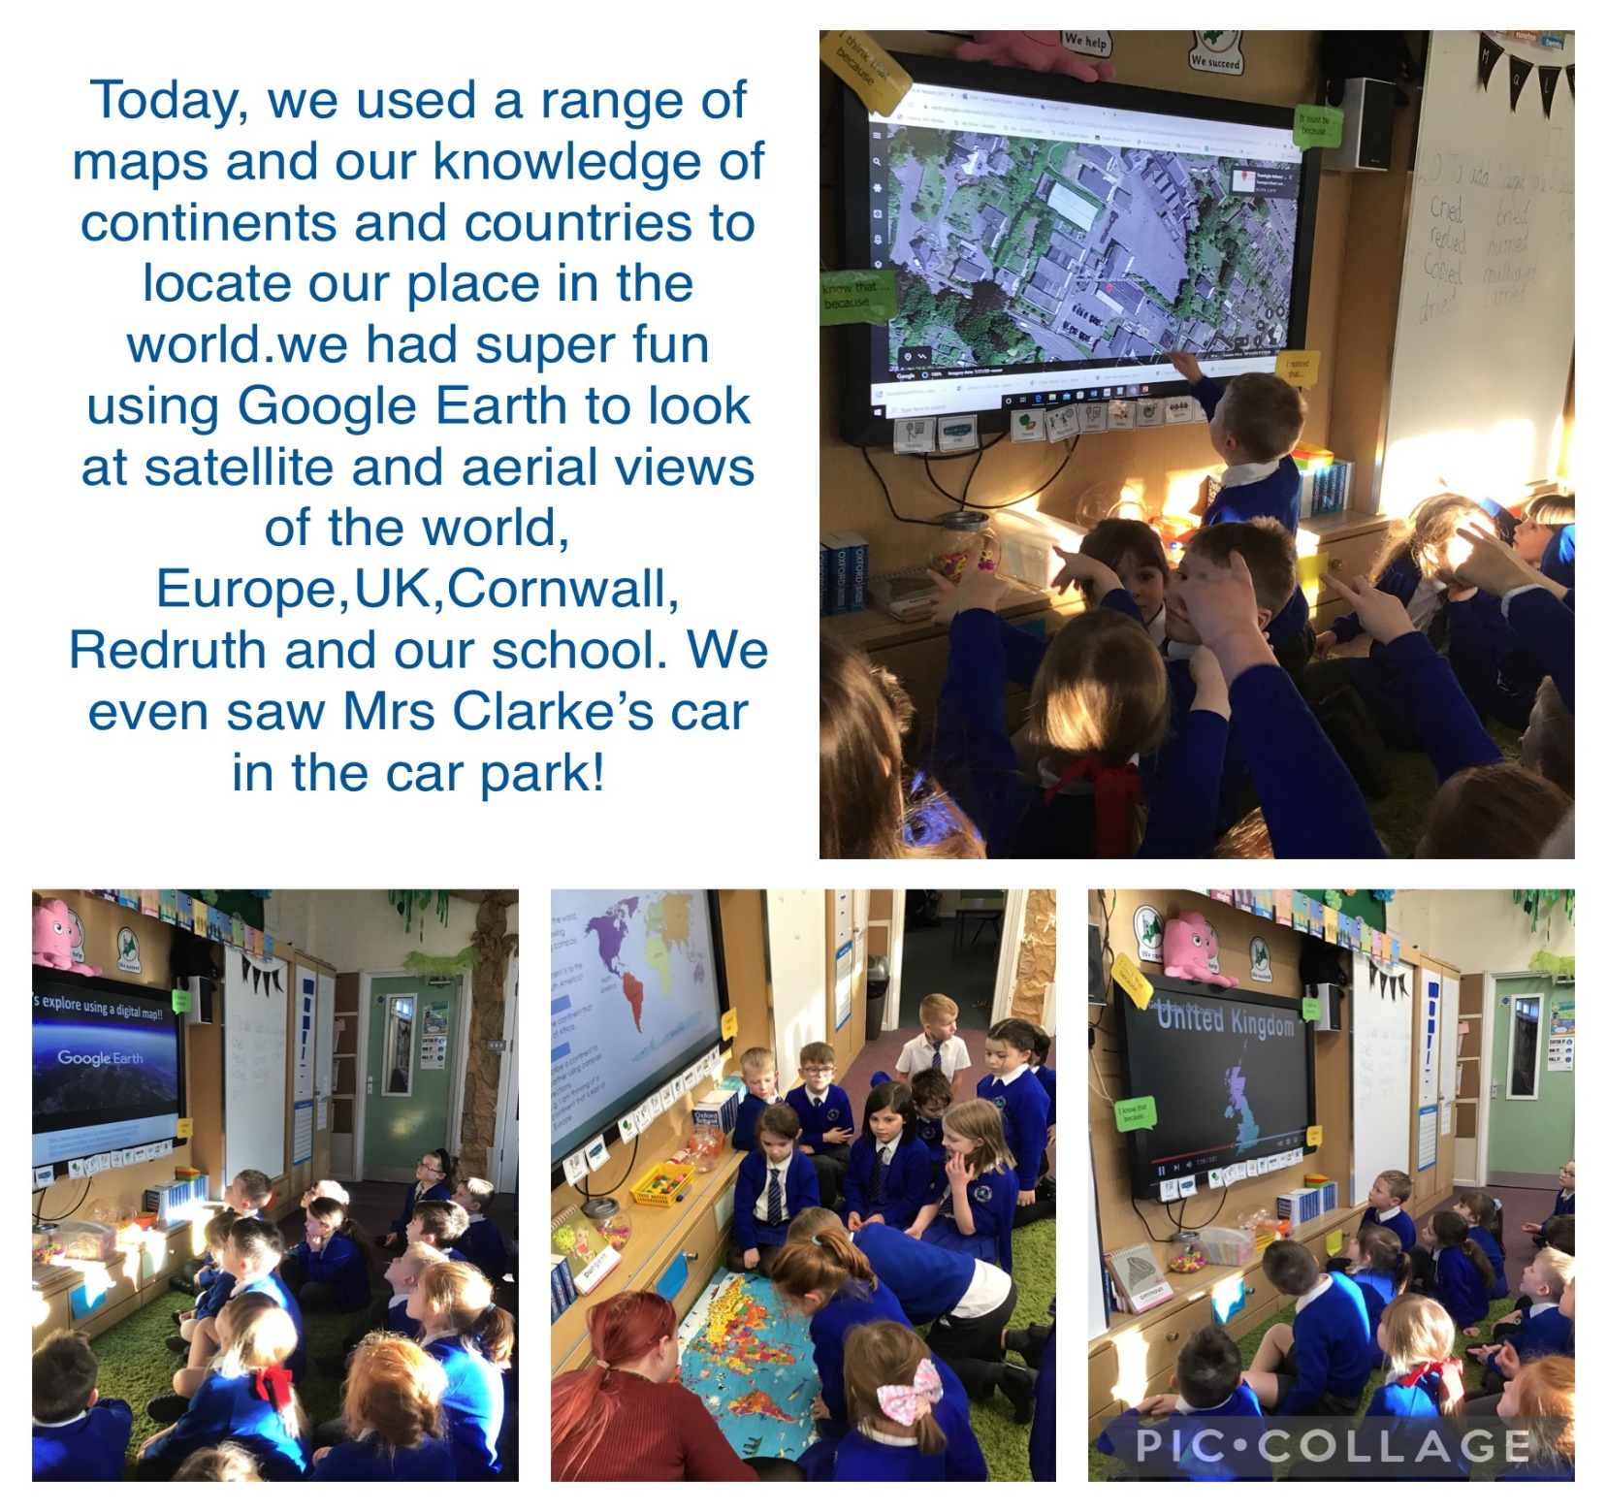
Monday 17th January 2022

L.O. To identify and locate where I am in
the world.
Google Earth is so cool, you can actually see my house. I’m going to find more things on the map at home!
Rivka

Rivka

